Preparing for A level – Study Support Pack: Summer 2022
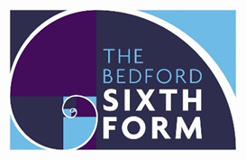

Subject: Politics

The aim of this pack is to help you bridge the gap between GCSE and A level. It is specific to one of the many A level subjects that are taught at The Bedford Sixth Form and we encourage you to work through all the relevant packs for the subjects that you would like to study.

www.bedfordsixthform.ac.uk

A Level Politics
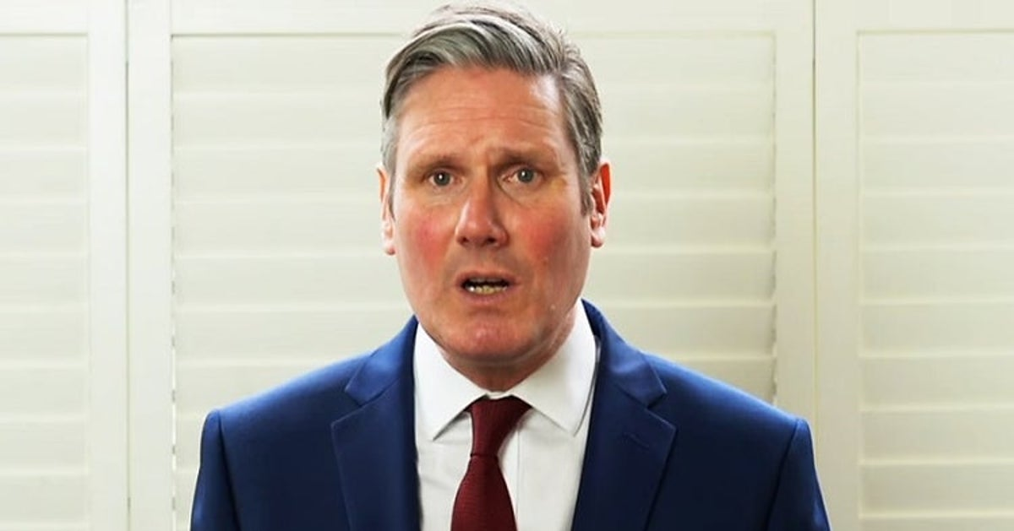
Welcome, to A level Politics, which you’ve chosen to take this September. The booklet is designed to give you a flavour of what A level Politics is all about. The pack will introduce you to some core political concepts and events, to aid your understanding of politics ready for sixth form. The work in this booklet will take a long time, so you can break it up. Don’t feel you need to complete it all in one go! You can complete the tasks in this booklet in the spaces provided. The completed work will need to be submitted in your first Politics lesson in September and you will be given a mark out of a 100
This job is a lot harder than I expected…
Contact Kim or Penny if you have any queries.

kprice@bedfordsixthform.ac.uk pcunningham@bedfordsixthform.ac.uk

A Level course outline
Year 12: UK Politics | Year 12: UK Government | Year 12-13: Ideologies | Year 13: US Politics
UK Democracy & Participation | UK Constitution | Liberalism | US Constitution & federalism
UK Parties | Parliament | Conservatism | US Democracy: elections, parties & interest groups
UK Elections | PM and Executive | Socialism | US Supreme Court
Voting behaviour and the Media | Relations between institution | Feminism | Congress & Presidency

Useful resources
One of the most important and overlooked things any student of politics can do is to simply watch and read the news. This is something that will be drilled into you from day one until the day you leave. Unlike any other subject the understanding of current affairs is paramount.
As such, I would like you to watch the news over the coming weeks and create a ten-question quiz to test the rest of the class next year:

1.
2.
3.
4.
5.
6.
7.
8.
9.
10.
10 marks
Below there will be a list of useful websites, newspapers, podcasts, and films.
Newspapers:
It’s always useful to read a wide range of newspapers and media, so do that as much as you can. Examples include: BBC news, The Guardian, The Independent, The Daily Mail, The Telegraph.
Podcasts:
Talking politics: https://www.talkingpoliticspodcast.com/
The New Statesman: https://www.newstatesman.com/writers/321845
Today in Focus: https://www.theguardian.com/news/series/todayinfocus
Websites:
https://blogs.lse.ac.uk/
https://www.tutor2u.net/politics
https://revisionworld.com/a2-level-level-revision/government-politics-level-revision
Films:
Secret world of Whitehall (YouTube)
Brexit: The Uncivil War. (Film)
The Iron Lady (film)
The West Wing (tv series)
Inside Obama’s White House (bbc tv series)

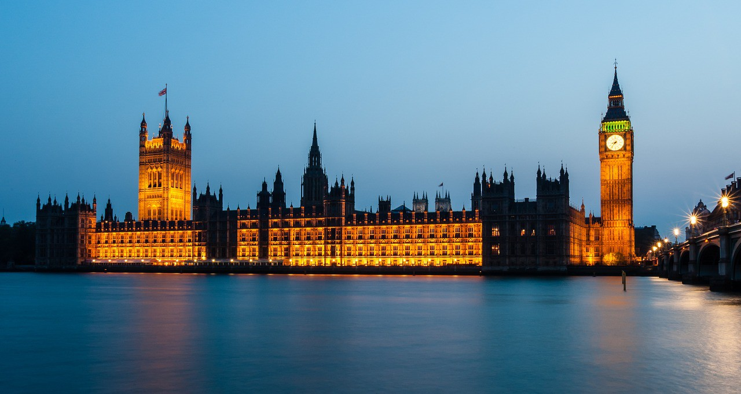
Quiz

- Who is the current UK Prime Minister?

- Who is the current leader of the Labour Party?

- Who is the current leader of the Liberal Democrats?

- Who is the current leader of the Conservative Party?

- What do the initials MP stand for?

- Where are the Houses of Parliament?

- At what age can you vote in Britain?

- Who is the current Chancellor of the Exchequer?

- Put these former Prime Ministers in chronological order: Blair, Thatcher, Cameron, Churchill, Brown.

- What is the term given to the area that is represented by an MP?

- How many of these areas are there in the UK?

- Who was the first female MP?
You will be awarded 1 mark for each correct answer (Total: 12 marks)

Task Two: What is Politics?
“Politics is the study of how a people, a nation or a state is governed.”

When most people think of politics, they think of old, wealthy men (only sometimes women, and only sometimes ethnic minorities) in offices, making deals and agreements that will affect millions of people, just for personal gain. And it’s true that some decisions are made that way, but politics is much more than that.
Politics is about power, about people, equality, war, conflict, debate, cooperation, freedom, money, etc. – it’s about the relationship between the state (the government) and its citizens, or the state and other states. It governs everything we can and will do in our lives.
One of the reasons politics is so exciting is that it changes every single day based on the actions of individuals. Less than 500 people (in a country of 330 million) decided the result of the 2000 presidential election that made George Bush president. In 2001 he invaded Afghanistan and in 2003 he invaded Iraq. These two things have changed the Middle East and global politics, perhaps forever. Closer to home, if just one out of every 50 people who voted to leave the EU had voted differently, we wouldn’t have left. Each individual vote is vital, and yet 28% of all the people who could vote and registered to vote in that referendum didn’t turn out on June 23rd. It would take just a small number of them to change the result.
Your first task is to help you garner an understanding of what Politics is really all about. Use the internet (e.g. Wikipedia, YouTube and other sources) to research and understand what the following key terms mean and create a short definition for each in your own words.
You are welcome to try to get your families involved in this – they may have some understanding of these concepts already! The most important thing in an A level is your understanding – so it’s not about having the “right” or “word-perfect” definition, it’s about you understanding what a concept means

Term | Explanation
Power
Authority
Legitimacy
Government
Politics
Civil society
Executive branch
Prime minister
Cabinet
Legislative branch
Parliament
House of Commons
House of Lords
Judicial branch
Rule of Law
Westminster Model
Elective dictatorship
Direct democracy
Representative democracy
Sovereignty
Parliamentary sovereignty
Referendum (UK – not US!)
Constitutional monarchy
Fusion of powers
Separation of powers
Devolution

You will be awarded 1 mark for each correct answer (Total: 26 marks)

Task Three: British Politics
Go to these links here for the UK’s three major parties:
https://www.bbc.co.uk/news/election-2019-50524262
https://www.bbc.co.uk/news/election-2019-50501411
https://www.bbc.co.uk/news/election-2019-50459123

These links summarise their key manifesto policies in the 2019 general election. I would like you to choose a few policies of your choice and explain below why you support OR do not support that policy. You must choose at least 1 policy from each manifesto to discuss your agreement to or opposition to (therefore compulsory is to do 3) – if you want to extend yourself and go further, you can do more than 3 by copying and pasting the spaces I have provided.

Party: __________________________
Manifesto policy: _____________________________________________________________________________________________________________________________________________________________________________________________________________________________________________________________________
Agree/disagree & why:
__________________________________________________________________________________________________________________________________________________________________________________________________________________________________________________________________________________________________________________________________________________________________________________________________________________________________________________________________________________________________________________________________________

Party: __________________________
Manifesto policy: _____________________________________________________________________________________________________________________________________________________________________________________________________________________________________________________________________

Agree/disagree & why:
__________________________________________________________________________________________________________________________________________________________________________________________________________________________________________________________________________________________________________________________________________________________________________________________________________________________________________________________________________________________________________________________________________

Party: __________________________
Manifesto policy: _____________________________________________________________________________________________________________________________________________________________________________________________________________________________________________________________________
Agree/disagree & why:
__________________________________________________________________________________________________________________________________________________________________________________________________________________________________________________________________________________________________________________________________________________________________________________________________________________________________________________________________________________________________________________________________________

You will be awarded 6 marks for each Party (Total: 18 marks)

TASK FOUR: MEMBERS OF PARLIAMENT
Research the role of your local MP.
I would like you to find out who your local MP is and create a profile/factfile that includes the following details about them:
- MP’s name:
- Political party:
- Constituency (the area they represent):
- Areas they have a particular interest in (look at their work in parliament – are they a member of a select committee, have they asked any ministerial questions, have they proposed any parliamentary debates? how have they represented their constituents). Start here https://members.parliament.uk/members/Commons
- And finally, look at their voting record (found here https://www.theyworkforyou.com/ by clicking ‘voting record’) and jot down some ways in which they’ve voted in parliament. For example, my MP when I was at university, Julian Sturdy (Conservative) voted against laws to promote same-sex marriage, and voted for increasing VAT rates.
(Total: 10 marks)

Task Four: Making a Case
Now I would like you to make a case for and against a particular issue. Politics at A level will require you to make judgements about issues. You need to create a for/against case for an issue that is close to you: for example - should we lower the voting age from 18 to 16?
This will require you to write at least three paragraphs (approximately ¾ to 1 full typed A4 page – but if you like you can write more). You can use websites like this: https://yougov.co.uk/topics/politics/articles-reports/2012/02/15/and-against-lowering-voting-age or Google search “for and against [issue]” to get more information about the issue at hand. I’ve written a sample paragraph below – I’m interested in you ARGUING your case with evidence!
Some who think we should extend the vote to 16- and 17-year-olds say that it may lead them to understand political issues more if they have to research them. If under 18s have to make choices on issues like taxes, the NHS and the size of the army, they would have to research them, so this will improve their understanding and they will make good choices. However, this argument doesn’t hold water because over-18s as it is rarely research political issues – if we don’t have adults researching taxes, the NHS or the size of the army before elections why would we expect children to? Therefore, this is not a good argument for extending the vote to 16- and 17-year-olds.
Write your paragraphs below (or type them). (Total: 12 marks)

Type/write here

Type/write here

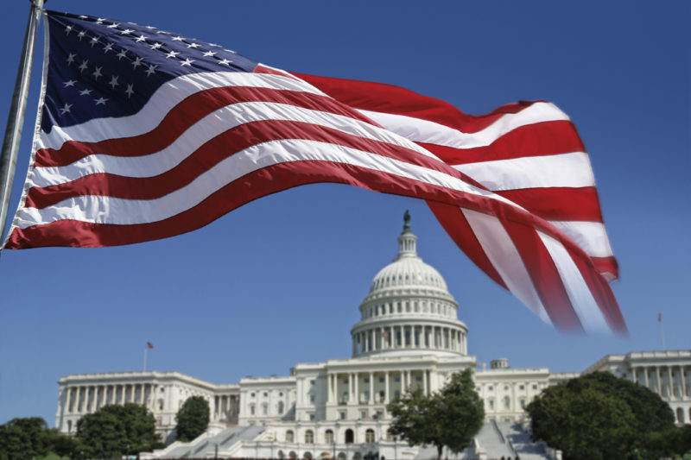
TASK 5: USA Research Task

Your research task is to choose one of the following parties: Republican Party or Democratic Party.
You need to research the history of the party, their ideology and policy beliefs (including their most recent election platform), their electoral performance (Is the current President from that party? Do they have a majority in Congress? How well did they do at the last elections (Nov 2020 for the President and Nov 2020 for Congress)? and finally key figures in that party (include photos and descriptions of who they are). This should be about one A4 page of typed work. You need to turn this into some sort of leaflet/flyer about that party including pictures, not just a set of notes.
Wikipedia is an excellent resource for this task (as a general rule, you shouldn’t rely on Wikipedia – but it IS a really good source of useful information!) but you should use more than one source to complete this work.
(Total: 12 marks)

You have finished your first assessment for A Level Politics – well done!

Total Marks for the completion of all tasks = 100

