Preparing for A level – Study Support Pack – Summer 2020

Subject: Psychology
The aim of this pack is to help you bridge the gap between GCSE and A level. It is specific to one of the many A level subjects that are taught at The Bedford Sixth Form and we encourage you to work through all the relevant packs for the subjects that you would like to study.

www.bedfordsixthform.ac.uk

At the Bedford Sixth Form we follow the OCR syllabus. Find out more here: https://www.ocr.org.uk/qualifications/as-and-a-level/psychology-h167-h567-from-2015/
Preparing for Psychology A-level study at BSF

We look forward to welcoming you to studying Psychology A-level with us at BSF and in the meantime we are suggesting some activities to help you use this time to prepare.
Task 1: Folder with contents page. Compulsory. 10 points.
*Firstly, when you join us we will ask you to have an A4 loose leaf file for your notes.
We would suggest you produce for yourself a contents page, the index to that folder, on A4 to place in the folder for the start of term.
The folder will be in two parts, one for each unit that we follow in year 1, and within each there will be a number of sections as listed below.

Contents page
• Introduction
Unit 1: Psychological Themes through Core Studies
• The Social Area
• The Developmental Area
• The Individual Differences Area
• The Biological Area
• The Cognitive Area
• The Perspectives

Unit 2: Research Methods
• Experiments
• Self Report
• Observations
• Correlations

If you have a folder with this contents page ready for the start of your A-level studies you will be off to a good start.

Task 2: Self-report – diary method. Compulsory. 20 points.

*Secondly we are asking you to begin some self report work by completing a diary.

The use of diaries can be very helpful as a research tool in psychology but we do not usually have the opportunity to explore this in a practical way.

- Please complete a diary for each week (Eg every Friday, you can set a series of reminders on your phone to make sure you do not forget) writing the day and the date and then just two sentences about how you currently feel about starting sixth form.

Record your entries on the next page.
Self-report – diary method

Please record your weekly responses here:

 | Day | Date | How I currently feel about starting sixth form
Week 1
Week 2
Week 3
Week 4
Week 5
Week 6
Week 7

Task 3: Nuremberg trials - research. Compulsory. 10 points.

Social Psychology
Below are two topics to research using the internet or any other sources you have to hand.
- Explore what you find and understand as background.
- Make some notes below for your own reference.

* Find out about the Nuremberg Trials.
When were they?

Why and where did they take place?

Who was Adolf Eichmann, and what was his defence to the charges he faced?

Think about his defence – in your own opinion, was it a reasonable defence for him to make?

We will be studying obedience as part of the Social Area of Psychology.
Task 4: Whistleblowing – research. Compulsory. 10 points.
*Find out about whistleblowing
What do we mean by whistleblowing?

- Find some examples from the news media of people who have blown the whistle and discover how easy or hard it was for them to do that

Find out what if anything it cost them – money, friends, job …. any costs at all or none?

- Be prepared to answer short questions about one person who was a whistleblower.

Think about what you would have done in their situation – would you have blown the whistle?

And why would you have done so, or not done so?

We will be studying whistleblowing as part of the Social Area of Psychology.
Task 5: Memory task . Compulsory. 10 points.
Memory
There are a number of different theories of how memory works – take a look at this one.
The Multi-store Model of memory: The Multi-store Model of memory states that memory has three separate memory stores; the sensory store, short-term memory (STM) and long-term memory (LTM).
Atkinson and Shiffrin (1968) (the psychologists who developed the theory) argue that information must pass through each stage in order for information to become an LTM.
- See if you can find out about Atkinson and Shiffrin’s theory and then complete the following:
- Firstly find out what any unfamiliar words mean, then label the boxes.
- Secondly choose the duration from this selection and add the duration to each store on the table:-

0-18 seconds Unlimited ¼ - ½ second

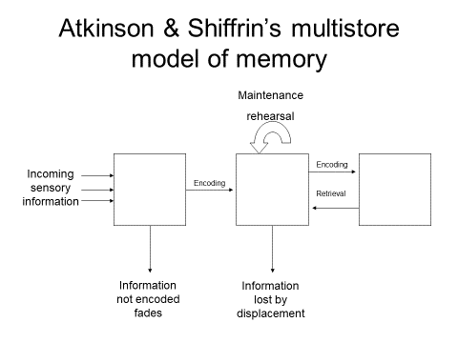
Task 6: Careers in Psychology . Compulsory. 20 points.
Careers in Psychology
Most students will begin A-level Psychology without having the opportunity to study it before. To help you know what the subject involves in a broader way it is useful to look at careers within Psychology.

- As this site explains, a Psychology degree gives you many transferable skills and for most people it is a great boost to their employability. Have a read of this page and look at the many different jobs where Psychology may be useful:
https://www.prospects.ac.uk/careers-advice/what-can-i-do-with-my-degree/psychology
Or search psychology prospects.

As you can see there are many different areas of employment where Psychology may be useful. Some graduates go on to train further for specific careers in Psychology.

- Find out about each of these career paths at the British Psychological Society (BPS) website:
https://careers.bps.org.uk/

- For each career path have a look at what the area involves (most have short videos you can watch). You do not have to read every page but you may want to follow the links further for any careers you find interesting.

- Write a few notes (one or two sentences maximum) about each area:

Forensic

Health

Clinical

Educational

Academia, research and teaching

Occupational

Counselling

Neuro

Sport and Exercise

Numeracy skills
An important skill for any psychologist is to be able to engage with and make sense of data. As a result all A-level Psychology courses include some Maths skills which are assessed in the exams. Many of the skills you will need will have been covered in GCSE Maths and Science but it is important to keep these skills fresh.
Task 7: Descriptive statistics table (next page). Compulsory. 20 points.
- The table on the next page is taken from OCRs GCSE Psychology website but all of the skills on here could also be tested in the A-level exam so now is a good time to practise them. Fill in the table as best you can.

Task 8 a-f: GCSE Maths Bitesize tasks. Optional. 10 points for each task (take a screen shot of the final page as evidence).
There are also many useful pages on the GCSE Bitesize website that allow you to practise skills you will need for A-level.
Follow these suggested pages and complete as many as you can including the tests along the way.
GCSE Bitesize Maths:
https://www.bbc.co.uk/bitesize/subjects/z38pycw

Find the GCSE Maths Bitesize page and choose the OCR exam board. Here, the relevant topics you should complete are:
- Probability
- Collecting data
- Analysing data
- Converting between fractions, decimals and percentages
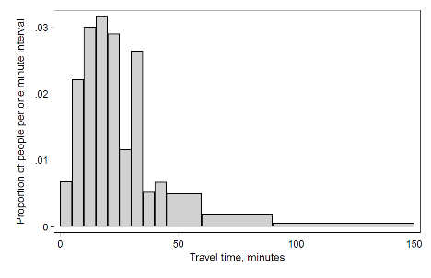
Find the GCSE Maths Bitesize page and choose the WJEC exam board. Complete the following topic from here:
- Histograms – Higher only

You could also complete this topic from the OCR page although it goes much further than what you will need to do in A-level Psychology:
- Fractions

Summary table for descriptive statistics
Mean – What is it and how to calculate? | Work out the mean for these data sets | Mode What is it and how to calculate? | Work out the mode for these data sets | Median - What is it and how to calculate? | Work out the median for these data sets | Range- What is it and how to calculate? | Work out the range for these data sets
 | 11,15,20,22,26,28,30  Mean =  2, 3,4,6,7,8,9,1,15  Mean = |  | 5, 6, 6, 7, 5, 6, 3, 9, 9,5 ,7  Mode =  11, 4, 5, 9. 9. 8, 9, 11, 12, 11  Mode = |  | 13,15,20,22,29,5,36  Median =  7, 11,4,6,12,8,14,1, 9  Median = |  | 4,8,6,15,3,11, 9  Range =  3.5.4.9.10.1.5  Range =
Ratio – What is it and how to calculate? | Percentages - What are they and how to calculate? | Calculate the following percentages | Fractions - What are they and how to calculate? | Convert these percentages in to fractions | Standard form – when used? | Decimal form – when used? | Examples of standard and decimal form
 |  | 16% of 30  52% of 90  13% of 73 |  | 25% =  50% =  67% =  89% = |  |  | Standard form  5,000,000 would be 5 × 106  65,000 would be 6.5 × 104  Decimal form  0.9 = 9/10  0.09 = 9/100  0.009 = 9/1000
Significant figures – why used and how to round off? | Examples of significant figures | Decimal places – converting decimal in to % | Decimal places – converting decimal in to fractions | Making estimations from data collected – when used? | Examples of making estimations | Definition of normal distribution | Example drawing
 | 1 significant figure: 423249 = 400000 (rounded down)  2 significant figure: 0.00379 = 0.004 (rounded up)  3 significant figures: 0.0040352 = 0.0040  (rounded down)  4 significant figures: 345,678 = 345,700 (rounded up) | Move the decimal 2 places to the RIGHT  Add % sign | For 2 decimal places divide by 100  For 3 decimal places divide by 1000  Find the lowest common denominator |  | With the figure 234 × 39.78 you might want to know “very roughly” what sort of value you are expecting rather than knowing the precise answer.  So we do an “order of magnitude” calculation which means rounding the numbers to 1 digit (1 significant figure), so we get: 200 x 40 = 8000
OCR Resources: the small print
OCR’s resources are provided to support the teaching of OCR specifications, but in no way constitute an endorsed teaching method that is required by the Board, and the decision to use them lies with the individual teacher. Whilst every effort is made to ensure the accuracy of the content, OCR cannot be held responsible for any errors or omissions within these resources.
© OCR 2017 - This resource may be freely copied and distributed, as long as the OCR logo and this message remain intact and OCR is acknowledged as the originator of this work.
OCR acknowledges the use of the following content:
Please get in touch if you want to discuss the accessibility of resources we offer to support delivery of our qualifications: resources.feedback@ocr.org.uk

