Preparing for A Level - Study Support Pack: Summer 2022

Subject – Physical Education
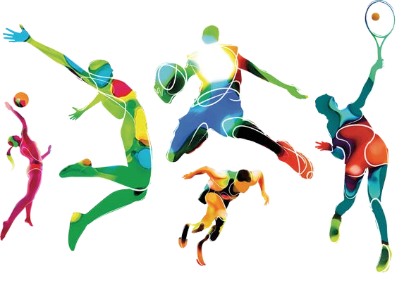

The aim of this pack is to help you bridge the gap between GCSE and A level. It is specific to one of the many A level subjects that are taught
at The Bedford Sixth Form and we encourage you to work through all the relevant packs for the subjects that you would like to study.
www.bedfordsixthform.ac.uk

Let’s get started!

Choose one sport of your choice from the list below, this sport will be your focus for the whole pack.
Activity | Comments | Tick Selected Activity
Association football | Cannot be five-a-side or futsal
Amateur Boxing
Athletics
Badminton
Basketball
Canoeing
Cricket
Cycling | Track or road cycling only
Dance
Diving | Platform diving
Equestrian
Golf
Gymnastics
Handball
Hockey | Field Hockey only – no ice or roller hockey
Hurling
Kayaking
Lacrosse
Netball
Rock Climbing
Rowing
Rugby League | Cannot be tag rugby
Rugby Union | Can be assessed as sevens or fifteen a side. Cannot be tag
Sculling
Skiing | Must take place on snow, can be indoor or outdoor
Snowboarding | Must take place on snow, can be indoor
Squash
Swimming
Table Tennis
Tennis
Trampolining
Volleyball

Task 1 – Performance Analysis (20 points)
Using the link below, read the article on Identifying a performer's strengths and areas for improvement:
https://www.bbc.co.uk/bitesize/guides/zy2qtyc/revision/2
You must find and watch a recent performance focusing on a single athlete in your chosen sport, and analyse their performance, try to pick out skills, tactics and fitness components.
Chosen sport
Chosen team and player name

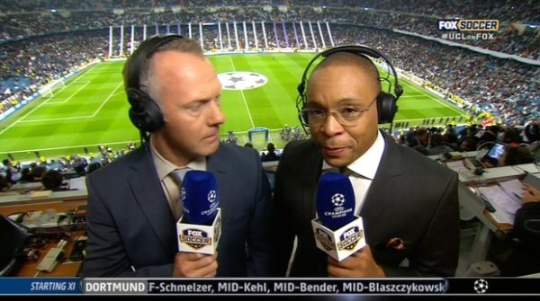
Performance SWOT Analysis:
Strengths (Things they did well) | Weaknesses (Areas they could improve)
Opportunities (Things they could do to improve) | Threats (Barriers they may have)

Task 2 – Data analysis (20 points)
The table below includes the fitness test results of your chosen athlete from a recent fitness testing session they took part in:
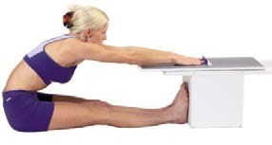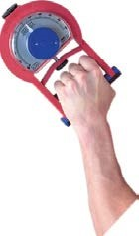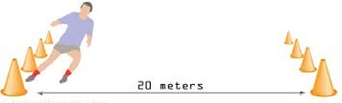

Fitness  component | Test |  | Attempts |  | Average | National norm score
 |  | 1 | 2 | 3
Aerobic Capacity | Multi-stage fitness test | Stage 11
Muscular strength | Hand grip dynamometer test | 30kg | 37kg | 38kg
Flexibility | Sit and reach test | 17cm | 20cm | 15cm

- You need to work out and fill in the average column.
- You need to then find the national norm tables for each test and compare their average score for each of the tests, and see how well your athlete did. A good website for this:
https://www.brianmac.co.uk/siteindx.htm

- Then you need to interpret the results, think about the component of fitness;

- How well your athlete did, was this a good or bad score for them?

- Do they require that component in their sport? If so why?

- Suggest which area your athlete should focus on improving, and why?

- How they might improve that area.

Task 3 – Planning a session (30 points)
This next task is all about the skill aspects of the chosen sport, you will be identifying key skills required for the sport, then classify those skills, and determine which type of practice would be best to use. Read the following to help identify your skills and practices.

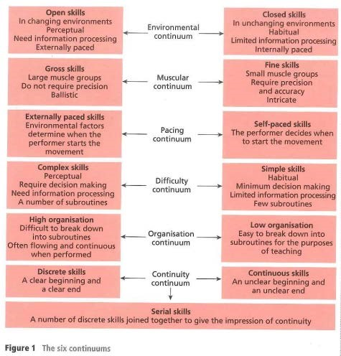
The four practice types
Before discussing practice types it is necessary to identify the major classifications of skills and to outline the characteristics of each skill when positioned at the extremes of the six continuums (Figure 1).
Fixed practice
Fixed practice is repetitive and undertaken in an environment or situation that remains the same. The practice type is good for teaching closed skills, which are classified as gross. Sprinting would fit with these categories but it is important to consider that after leaving the starting blocks the movement on the track is a continuous skill. Fixed practice also benefits discrete skills that are closed and gross, such as serving in tennis and driving in golf.

Varied practice
Varied practices, by contrast, take place in changing environments. As a result the practice changes constantly, which is more reflective of situations that arise during invasion games. For example, football players would practice passing and shooting in different situations. Varied practices are good for teaching open skills that have a perceptual content. While replacing the game situation, this type of practice stimulates interest and tends to motivate performers.
Massed practice
Massed practice is useful for teaching closed or discrete skills. In this respect it is similar to a fixed practice. Massed practice is also repetitive, but undertaken with no rest intervals. It can be used only for skills of short duration and low energy output, such as setting in volleyball. Skeet shooting is located at the closed end of the environmental continuum and can also be identified as a discrete skill. Massed practice may be long in duration and will therefore replicate both the physical and psychological demands of the competitive situation. As performance of this Olympic discipline requires rhythm and prolonged concentration, massed practice can greatly enhance the proficiency of skeet shooters.
Distributed practice
In contrast, distributed practice is undertaken in short bursts with regular rest intervals. This format would be good for skills that are continuous and have high energy output, such as sprinting. Distributed practice is versatile. It can be applied not only to closed skills like sprinting but also to complex movements with perceptual requirements, such as dribbling the ball in hockey. In addition, rest breaks are advisable when coaching skills that have elements of danger, such as the gross skill of tackling in rugby.

Complete the following activities based on the information you have just read on skills and practices.
- List 5 important skills in your chosen sport and identify how they should be classified on each continuum.
Skill | Environmental (open/closed) | Muscular (gross/fine) | Pacing  (self/externally) | Difficulty  (simple/complex) | Organisation (low/high) | Continuity  (discrete/serial/ continuous)
e.g. passing | Open | Gross | Externally | Simple | High | Discrete

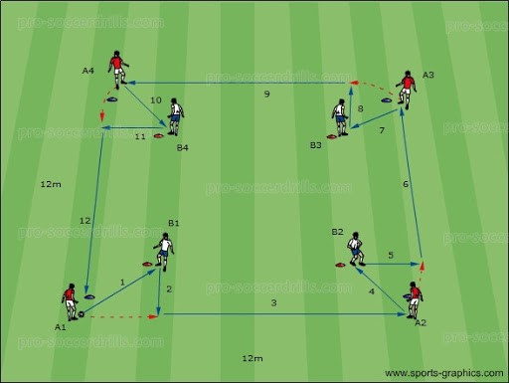
- For each of your 5 skills, you must now decide which type of practice would be most suitable for it, and why.
Skill | Type of practice | Justification

Referring back to your original performance analysis in task 1, you must plan a training session for your athlete/team, to improve a skill you have identified as a weakness.
 | Session plan
Aim:
(skill focus)
Objectives:
(break down
parts of skill)
Facilities |  |  |  |  |  | Equipment list
Purpose of activity |  | Name and description of activity  Use written descriptions and/or diagrams |  |  |  |  |  | Adaptation Suggest 1 change to make each activity more/ less challenging
Introduction a  Warm up | nd
Main session (include progressive practices)
Cool down and close
Other things to remember/ aware of, e.g. safety

Task 4 – Research (30 points)
Research skills are essential in A level courses. In particular, your research will help you to explain and evaluate concepts. You will also be taught how to record and evidence where you have found your information, this is called referencing.
You should NEVER use Wikipedia as a source in your work! Why is that?

Your research task is to look for any sociological issues there may be in your chosen sport.
Research one of the issues listed below:
Sociological Issues:
- Gender issues e.g. inequality, sexism, and homophobia.
- Deviance e.g. gamesmanship, doping, violence, corruption
- Socioeconomic issues e.g. opportunities, access, financial, privilege, and stereotypes.
- Racial/cultural issues e.g. abuse, opportunities, stereotyping, stacking.
- Political issues e.g. use of sport to tackle social problems, exploitation of sport.
- Legal issues e.g. sport (and society) more litigious, growth of sports law.
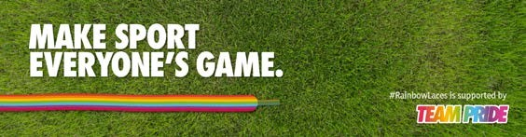
- Give a summary of what this issue is generally, with examples of how it can impact your chosen sport:

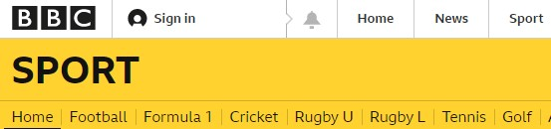
- Search ‘BBC news [sport and issue]’ e.g. ‘BBC news football racism’ and pick an article about the issue in your sport that you think is interesting.
  - What is the title of the article and when was it published?
  - Describe the story and then explain: What impact does it have on the sports performers?
  - How do you think National Governing Body e.g. FA, might react to the story?
  - Summarise the example of the issue from your sport, who did it impact, how did it impact them? What was done about it?

- Make some suggestions on how this issue could be overcome in the future, you could research some current initiatives that are in place to try and manage the issue.

WELL DONE!
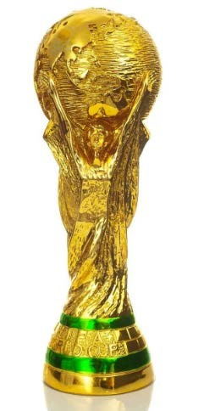

By completing this subject pack you have given yourself a great start for when you join the Physical Education course in September.
This pack has covered skills in research, writing, using numbers in context, analysis and planning.
Please bring your completed pack with you to your first Physical Education lesson!
We hope you enjoyed completing this work and are excited to start in this subject. In the meantime please keep up to date with the news, we recommend reading the articles here weekly:
https://www.bbc.co.uk/sport

See you soon,
The sport team

