Preparing for A level – Study Support Pack – Summer 2022

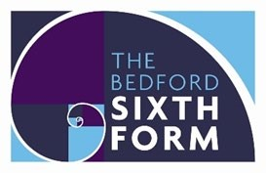

Subject: Media Studies

The aim of this pack is to help you bridge the gap between GCSE and A level. It is specific to one of the many A level subjects that are taught at The Bedford Sixth Form and we encourage you to work through all the relevant packs for the subjects that you would like to study.

www.bedfordsixthform.ac.uk

Welcome to A level Media Studies!

We are delighted that you would like to study Media Studies at The Bedford Sixth Form.

This pack is designed to ensure that you are ready for the start of your A level course. Please bring your completed pack to your first lesson in September.

You will find several activities throughout this pack. The tasks you complete are worth points. You must complete tasks worth a combined 100 points as a minimum. Your teacher will check this work in your first lesson in September.

ACTIVITY 1

C
an you spot

all

27
film references

in the image below?

The
answers are on page 13. (10 points)

Introducing the theoretical framework
Media Studies at A level can be broken down into four key areas of study, known as the theoretical framework.
The four areas are:
- Media language
- Representation
- Media industries - Audiences

Some media forms you study will involve all areas of the theoretical framework, while others will only involve parts of the framework.
This pack will help you get to grips with each area of the framework, and will introduce you to some relevant terminology and theory.
ACTIVITY 2 | In general, media refers to various means of communication.  The role of the media is to interpret the real world and communicate information to audiences.  In total, there are nine media forms studied at A level. Film is one form. What do you think the eight others might be? Come up with your own list, (10 points)

Media language

Media language is defined as:
How the media through their forms, codes, conventions and techniques communicate meanings.

Key terminology Key theories
Semiotics Roland Barthes -Semiotics
Codes and conventions Claude Levi-Strauss – Structuralism
Denotation Steve Neale – Genre theory
Connotation Tzvetan Todorov – Narratology
Intertextuality
Iconography
Mise en scène
Binary oppositions
Anchorage

ACTIVITY 3 | Start your own Media Studies glossary. (20 points)  Begin your glossary by looking up the meanings of the key terms on this page. You could also find a brief summary of the theories.  Write your glossary in your own words. This will help you understand the concepts better.  You will add to your glossary as you go through this pack and are introduced to other areas of the theoretical framework.

Semiotics
An important part of media language is semiotics, which is defined as the study of signs.
Signs are any elements of a text which create meaning for the audience. In print texts, such as film posters and advertisements, the signs are text and images. In audio-visual texts such as television programmes and films, signs can include mise en scène (everything seen in each frame), sound, camera work and editing.
According to the media theorist Roland Barthes, these signs have denotative and connotative meanings. The denotation is the literal meaning of the sign – what it actually means. The connotation is the associated meaning – what it makes you think of.
A useful guide to semiotics can be found here: www.englishbiz.co.uk/semiotics/index.html A useful guide to camera work can be found here:
www.empireonline.com/movies/features/film-studies-101-camera-shotsstyles/
We recommend that you study these guides carefully before moving on to the next activity.
ACTIVITY  4 | Choose a film poster to analyse using semiotics. (20 points)  You need to break the poster down into the signs and codes it consists of. List the images shown, any text, use of colour, layout, camera shots etc. Then consider the denotative and connotative meanings.  Use the example on the next page to help you understand how to explore denotations and connotations.

Denotation: He is wearing clown make-up

Connotations: Clowns are traditionally associated with humour and happiness, which is the opposite of how he appears. Some audiences will associate the image with previous versions of the Joker character – villainous, mentally unstable, dangerous. The pale make-up connotes death and illness, the red connotes blood and danger.
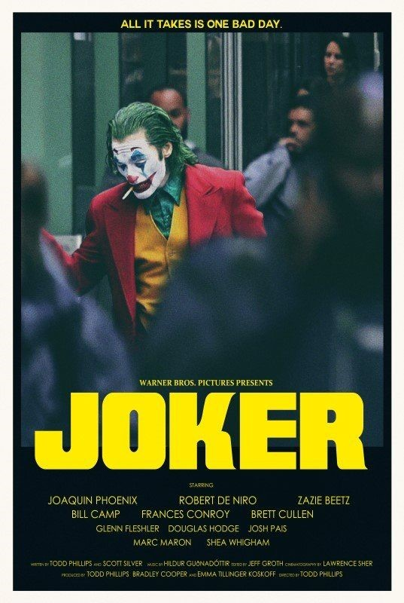
10 points

Denotation: He is
looking down at the
floor with his
shoulders slumped.

Connotations: His
body language
connotes his
unhappiness and
dissatisfaction with
life. This contrasts
with his ‘clown’
appearance, but the
running make-up also
looks like tears.

Denotation: He is
smoking a cigarette

Connotations: Bad
health, rebellion,
arguably an old-
fashioned thing to do
which positions him
as an
outsider.

Denotation: He is
wearing bright clothes

Connotations: He
stands out from
everyone else. Red can
be associated with
danger and violence,
yellow associated with
illness and decay
.

Denotation: He is sitting on public
transport

Connotations: Public transport has connotations of the ordinary
and mundane, sometimes associated with a lack of success. The
other people are out of focus; he stands out in a negative way.

ACTIVITY  5 | 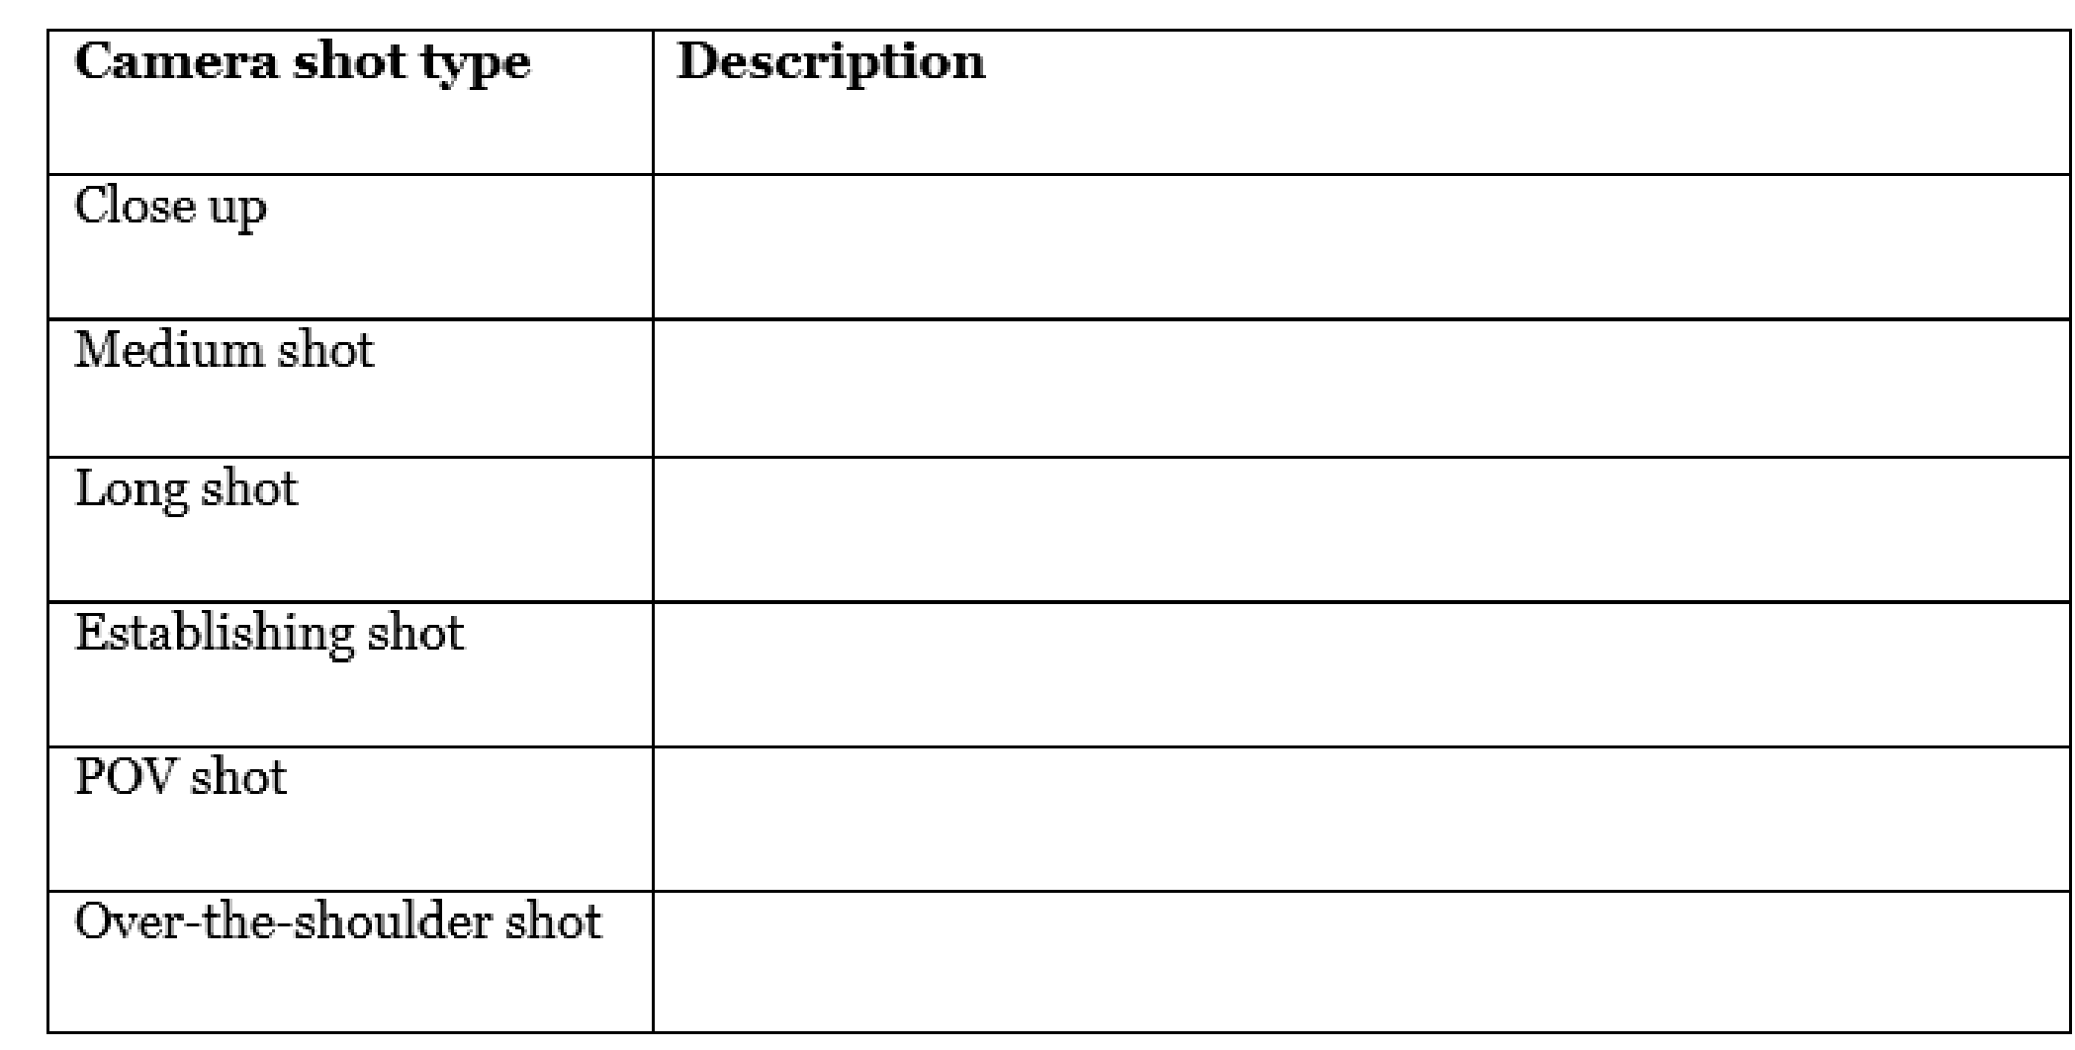

Representation

Representation is defined as:
How the media portray events, issues, individuals and social groups.

Key terminology Key theories
Stereotype David Gauntlett – Identity theory
Under-representation Stuart Hall – Representation theory
Ideology
Tokenism

Hegemony
Ethnocentrism
Mediation
Patriarchy

ACTIVITY  6 | Add to your Media Studies glossary by researching the meanings of the terms and theories on this page.  20 points

Representation in music videos
ACTIVITY 7 | Can you name the artists and songs from these music videos? (10 points)

How to analyse representation in music videos

- While watching the video, note down which events, issues, individuals or social groups are being represented
- Consider how stereotypes are used. Are they used positively or negatively?
- Consider how elements of media language such as camera work, mise-en-scene and editing create these representations (For example, a low angle shot may be used to show power or dominance)
- Consider how the video demonstrates the values and attitudes of the producer. What position do they want the audience to take?
ACTIVITY 8 | Using the guidance on the previous page, write up an analysis of how representations are constructed in any music video of your choice. Here are some suggested videos with interesting representations:  Taylor Swift – You Need to Calm Down (20 points)  https://www.youtube.com/watch?v=Dkk9gvTmCXY  Dizzee Rascal – Dream – 20 points https://www.youtube.com/watch?v=KG7KDsuRQXo  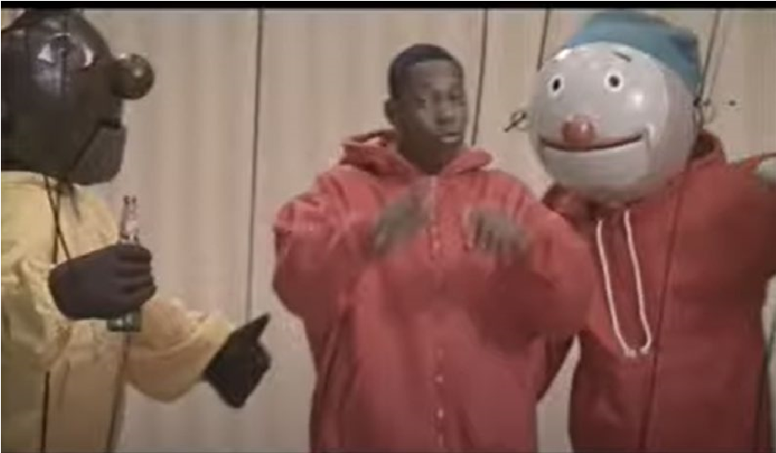  Beyoncé – If I Were a Boy- 20 points -https://www.youtube.com/watch?v=AWpsOqh8q0M  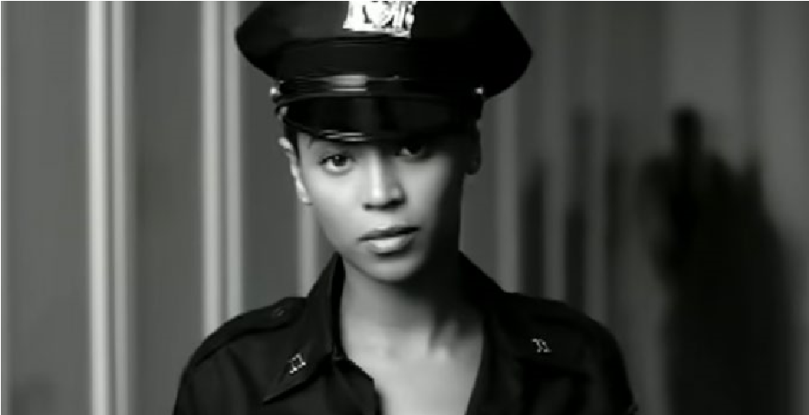

Media Industries

The study of media industries is defined as:
How the media industries' processes of production, distribution and circulation affect media forms and platforms.

Key terminology Key theories
Production Curran and Seaton – Power and Media Industries Distribution
Circulation
Conglomerate
Vertical integration
Horizontal integration
Media concentration
Diversification
Cross-platform marketing
ACTIVITY 9 | Add to your Media Studies glossary by researching the meanings of the terms and theories on this page. – 20 points

ACTIVITY 10 | Research the three media conglomerates below and complete the table. Which conglomerate is most powerful? (20 points)  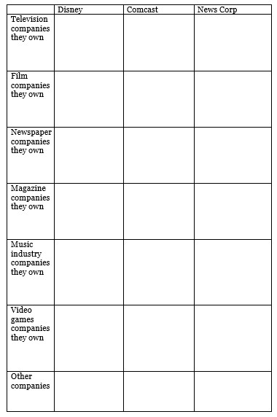

Audiences

The study of audiences is defined as:
How media forms target, reach and address audiences, how audiences interpret and respond to them, and how members of audiences become producers themselves.
Key terminology Key theories
Demographics Stuart Hall – Reception theory
Psychographics George Gerbner – Cultivation theory
Active audience Albert Bandura – Media effects
Passive audience
Socioeconomic groups
Prosumers
Cultural capital
Niche audience
Mass audience

ACTIVITY  11 | Add to your Media Studies glossary by researching the meanings of the terms and theories on this page. – 20 points
George Gerbner’s cultivation theory suggests that exposure to the media can shape and influence the way in which people perceive the world around them. Write down how each of the newspapers below do this. (20 points)
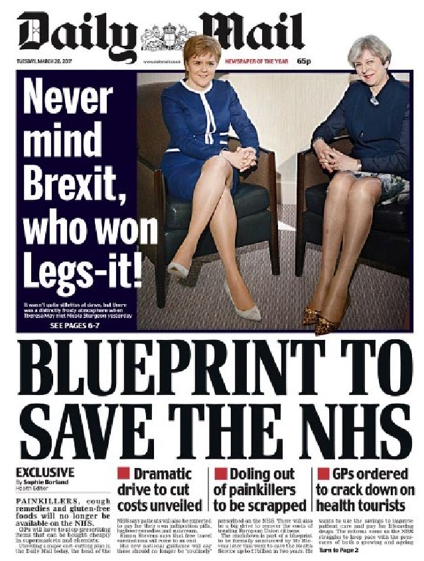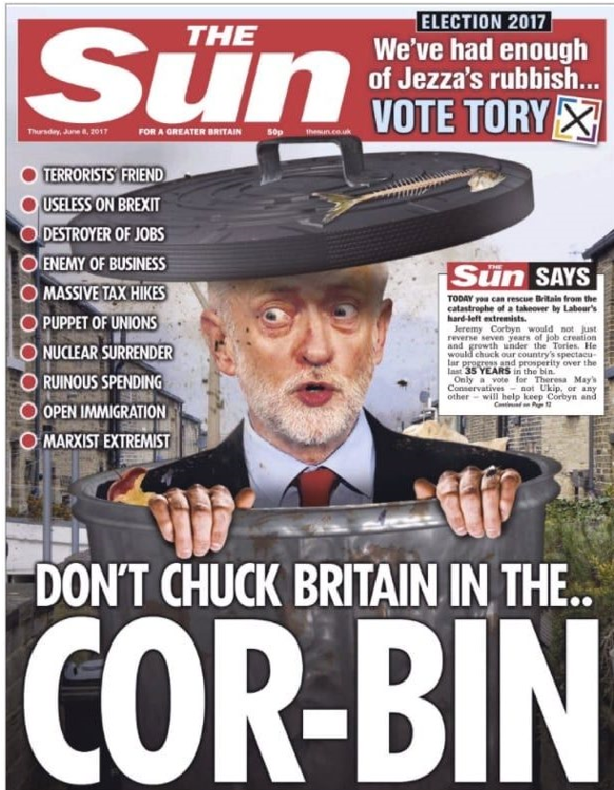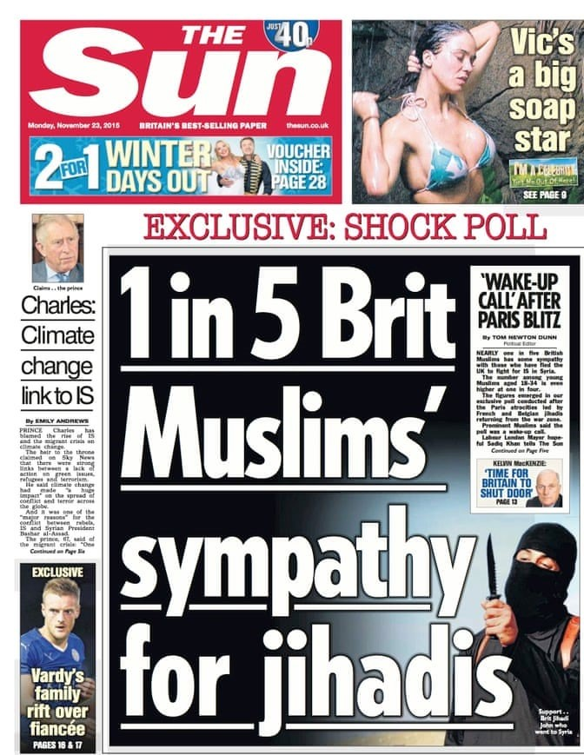
ACTIVITY
12

Useful links and extra reading

Leading newspaper front pages, updated daily:
www.bbc.co.uk/news/blogs/the_papers
Free Media Studies digital resources from Eduqas:
resources.eduqas.co.uk/ BBC’s The Media Show:
www.bbc.co.uk/programmes/b00dv9hq
Media news from The Guardian: www.theguardian.com/uk/media
The Media Insider on YouTube:
https://www.youtube.com/channel/UCGXfqzVEZr0XaZLWG3_HniA
Media news from the BBC: www.bbc.co.uk/news/topics/c207p54mlzpt/media

