|  |
| --- |
| **Preparing for A level History**  **Study Support Pack**  **Summer 2022** |
|  |
| The aim of this pack is to help you bridge the gap between GCSE and A level History or to help you start if you did not take GCSE History. It is specific to one of the many A level subjects that are taught at The Bedford Sixth Form.  You are required to read through this guide and answer the subject questions in this pack and hand in the work when you begin your course in September. You can either submit this before your first lesson electronically (by emailing Kim or Penny) or complete by hand in a printed copy in your first lesson.  You will be awarded a mark out of 100 – and the marks for each question are indicated with each question. Some of the marks are for accuracy but others are awarded for effort and analytical skill, so ensure you have a go at each question.  Good luck and we look forward to welcoming you to History in September! |
| [**www.bedfordsixthform.ac.uk**](http://www.bedfordsixthform.ac.uk/) |

**Welcome, year 11!** This is your ‘Bridging the Gap’, booklet for A level History. The pack is designed to give you a flavour of what A-level History is all about. The pack will introduce you to some core concepts and events, to aid your understanding of the topics ready for sixth form. Do not feel you need to complete it all in one go!

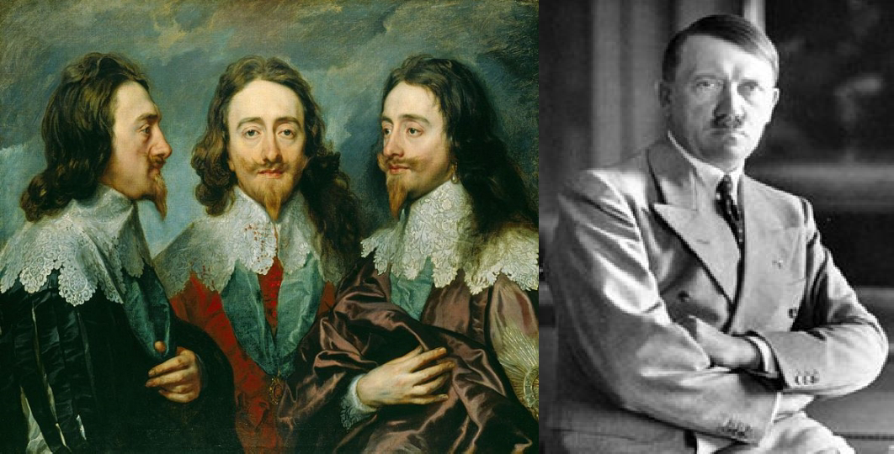

### Contact Kim or Penny if you have any queries:

[*kprice@bedfordsixthform.ac.uk*](mailto:kprice@bedfordsixthform.ac.uk)[*pcunningham@bedfordsixthform.ac.uk*](mailto:pcunningham@bedfordsixthform.ac.uk)

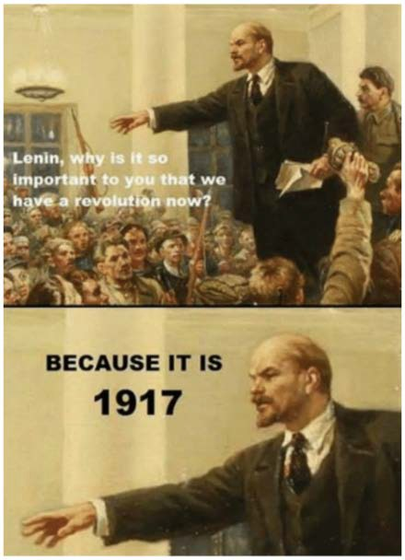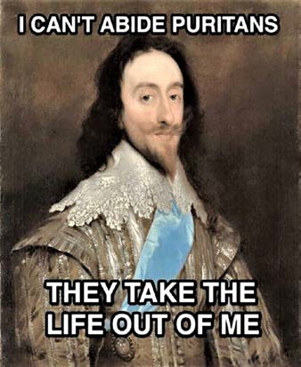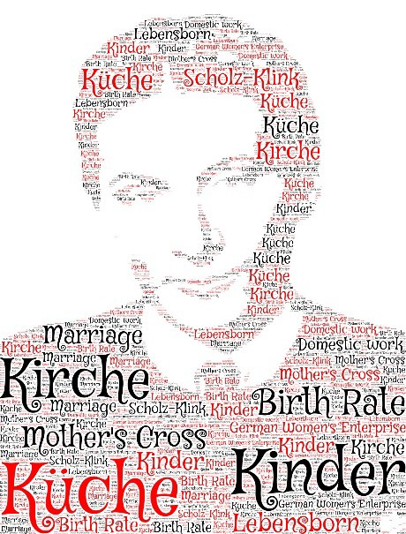

### The two-year History A Level consists of two subjects, each with their own exam paper (paper one and paper two). There is also an independent coursework element for 20% of your final grade, which is completed in Year two. Your taught course is therefore split into two thematic courses (Stuarts and Germany) spread over the two years: half of your lessons will be about the Stuart period and the other half of your lessons will be focused on Germany’s experience with the Weimar Republic and Nazi rule. You will therefore have two history teachers throughout the year.

|  |  |
| --- | --- |
| **AQA Paper 1 HIS 1D: Breadth Paper Stuart Britain and the Crisis of the**  **Monarchy 1603-1702** | **AQA Paper 2 His 2O: Depth Paper Democracy and Nazism: Germany**  **1981-1945** |
| **Non-Exam based assessment (NEA) Independent study (Coursework)**  **Russian Dictatorships 1855-1956: 3500-4500 words** | |

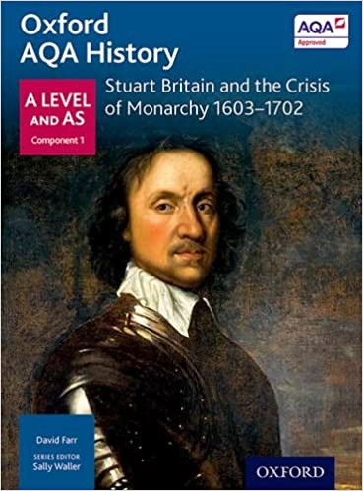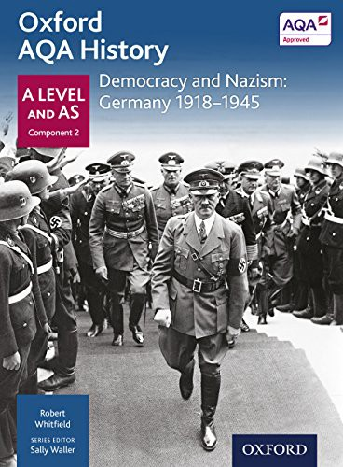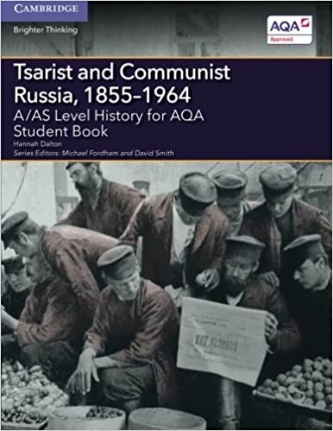**Books** – you will need to purchase the following three books:

**Additional books** that you may like to read (you don’t necessarily have to buy and read all of these over the summer):

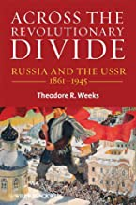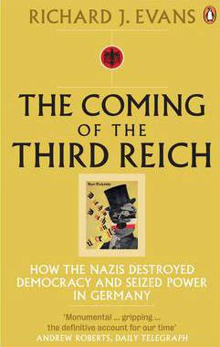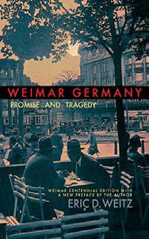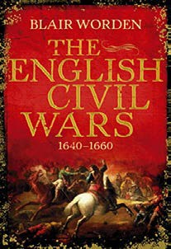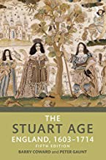

#### Videos:

*Fit to Rule: Tudors to Stuarts* (From Gods to Men) – Starts with Henry VIII but stick with it or forward to 34min into the programme and the section on the Stuarts begins <https://www.youtube.com/watch?v=WFKOnp-DQT4>

## Paper 1 (Stuarts): Year 12 content

## Absolutism Challenged, 1603-1649

The Stuart period ended over three centuries ago, but it continues to have an impact on Britain (and the world!) today. The shape of Britain’s social, religious and political environment was formed in this period. Although life in the British Isles has changed significantly since that time, some of the most important aspects of life, date back to then – such as religious toleration, democratic parliamentary processes and constitutional monarchy. Despite the Stuart period being one of the most interesting and exciting periods of British history, it is also one of the most complicated! It is highly likely that the majority of you will not have studied the Stuarts before and therefore have no idea where they fit in the long and complex history of Britain. The first couple of tasks set for the summer will therefore help you to develop some knowledge and understanding of this period.

**Task 1: Who were ‘The Stuarts?’ Answer the following questions after watching the video at** [**https://www.youtube.com/watch?v=SlsmMFnKg3Q**](https://www.youtube.com/watch?v=SlsmMFnKg3Q%20) **[10 marks]**

1. Why was James VI of Scotland the rightful heir to the English throne?

Type answer:

­­

1. Which religious group created the Gunpowder Plot happen?

Type answer:

1. What were court ‘favourites’ and give an example of one?

Type answer:

1. Why were the monarch’s relations with Parliament ‘stormy’?

Type answer:

1. How did Charles fashion himself and how did this represent a change from James?

Type answer:

1. Why and for how many years did Charles rule without Parliament?

Type answer:

1. Why was Charles forced to recall Parliament?

Type answer:

1. Which foreign campaigns did Charles fight in 1625 and 1627? Were these successful campaigns?

Type answer:

1. What were the two sides in the English Civil War?

Type answer:

1. How did Cromwell consolidate his position after 1653 and what was his title?

Type answer:

## Task 2: Create definitions for the following key-terms [10 marks]

Studying the 17th century means that you have to get grips with some new terms and it is important that you have good grasp of their meaning and can use them appropriately in your work. When creating the definitions – **do not simply copy and paste – put the definitions in your own words** – so you understand their meaning and can use the terms appropriately in your writing

1. Absolutist

Type answer:

­­

1. Feudal

Type answer:

1. Aristocracy

Type answer:

1. Legislation

Type answer:

1. Bedchamber

Type answer:

1. Monopolies

Type answer:

1. Divine Right

Type answer:

1. Patronage

Type answer:

1. Ecclesiastical

Type answer:

1. Personal Rule

Type answer:

## Task 3: construct your own timeline of rulers from 1603-1714 [30 marks]

Do some additional research to create a timeline of rulers from 1603-1714 – make sure you include their names, pictures, dates of rule, how they became the ruler, how they lost the throne and at least 1 key event from during their rule. The most effective way to do this would be to use software, such as Word or PowerPoint or Google sheets and send your timeline to Kim or Penny (emails above) or you can complete by hand and give this in at your first lesson. Think about political, economic and religious change and continuity. You can research this using https://www.royal.uk/stuarts and [https://www.britroyals.com/tudortree.asp](https://www.britroyals.com/tudortree.asp%20) - if you click on each monarch you will get a fact file.

# Paper 2 (Germany): Year 12 content

**Germany 1918 – 1933.**

Germany has one of the richest, contrasting but ultimately catastrophic histories in Europe. Prussia was the biggest Germanic nation. It gave birth to and embraced the European enlightenment. Yet, together with Austria and Russia it divided up and ruled over Poland for three centuries. Towards the end of the nineteenth century, Germany united under a federalised Germanic ‘Second Reich’, ruled by a Kaiser with desires for a mighty Germanic empire to rival Britain’s. The clash of empires led to WWI. Millions died before Germany surrendered in 1918. A peace treaty was signed that brought the once mighty Germany to its knees. Revolution followed and a shaky democracy was established under the Weimar Republic. Threats from the far left and the far right consistently destabilised the fragile democracy. Ultimately, the German nation craved its rehabilitation to power, which (among other things!) led to the popularity of the Nazis and Weimar’s downfall. You will learn about all of this in Year One, before learning in Year Two of the horrors unleashed by Nazi totalitarianism and the causes and effects of Germany’s role in WWII.

**Task 4: Construct your own timeline of the Weimar Republic [30 marks]**

Do some additional research to create a timeline of key events in Germany from 1918 to 1933. The most effective way to do this would be to use software, such as Word or PowerPoint or Google sheets and send your timeline to Kim or Penny (emails above) or you can complete by hand and give this in at your first lesson. Think about political, cultural and economic change and continuity and significance. Try to find about ten significant events. This might be for economics, politics, culture or social processes and themes – and some of this might be related to key personalities. Don’t worry if you can’t find ten events but do try to find as many as you can.

**Task 5: Key Personalities – Research and make notes on two individuals in (a) and (b) below. [10 marks]**

Think about their background, their actions and contributions to Germany at this time - in what ways did they shape German history after WW1?

|  |
| --- |
| 1. **General Erich Ludendorff:**   Type answer: |
| 1. **Field Marshal Paul von Hindenburg:**   Type answer: |

**Task 6: A map of German states during the Weimar Republic. Add the following modern cities to the historical map of German states during the Weimar Republic [10 marks]**

The most effective way would be to use software, such as word, and insert a textbox and write the name of the city at its location or link up the names below using lines to show the approximate location. However, this can be done by hand, if you are completing it by hand/printed hard copy.

1. Berlin
2. Munich
3. Cologne
4. Dortmund
5. Weimar

