A LEVEL FINE ART
Y11 SUMMER WORK
JOURNAL
DEADLINE: September 2022
Please bring your journal in with you to the first lesson. This will be assessed work.
Over summer you are going to be producing a journal showcasing different fine art skills, ideas and subject knowledge. Use this as an opportunity to show your strengths and convey who you are as an artist before starting the course. This journal will let your teachers know what your area of interest is, technical skills you have and your intentions for after sixth form.
TASK
- Please use a small sketchbook for your journal, we recommend sizes A5/A4. If this isn’t accessible for you then you could document your work and display it on a PowerPoint instead.
- Each section of your journal will be worth points, the more work you do and the harder the task the more points it will be worth.
- Consider how you are presenting the journal, this will give your teacher an idea of your ability to layout a sketchbook (please look at the examples for inspiration).
- Your journal should go in order of the tasks below.
- [5 points] To begin your journal introduce yourself! Who are you? Where did you go to school before BSF? What are your goals after studying A-Levels?
- [5 points] Produce a moodboard of 10 images showcasing your interests within fine art, think about what you are excited to try at A Level and what area you want to focus on. This could include styles, mediums, artists or other forms of inspiration.
- [10 points] Create an outcome in the medium you think is your strength, whether this is pencil, collage, paint or pastel. The subject matter can be anything you like!
- [10 points] Select an artist who you find inspiring and produce a piece of work either directly copied or inspired by them.
- [20 points] Create an outcome in a style you are interested in, are you more illustrative? Or like to work realistically? Do you enjoy working 3D?
- [20 points] Take photos of your own to work from so the piece is original, show the photoshoot in your book and then select the strongest image to create an outcome from in any medium/style you like.
- [30 points] Select a medium that challenges you and you are not comfortable with, to finish off your journal create an outcome using this. Once you are done, write a short reflection considering what you think went well or you could improve on next time.
A LEVEL FINE ART
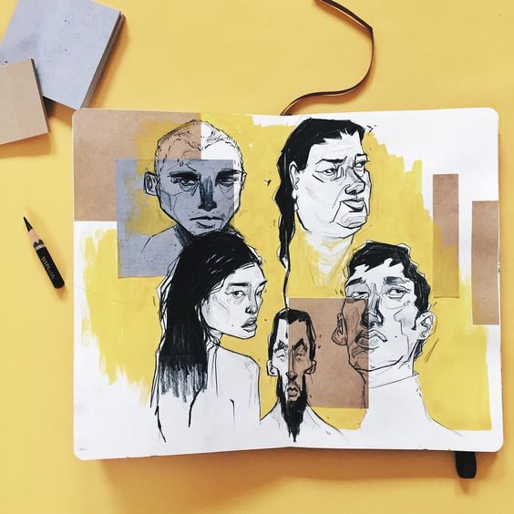
JOURNAL EXAMPLES
