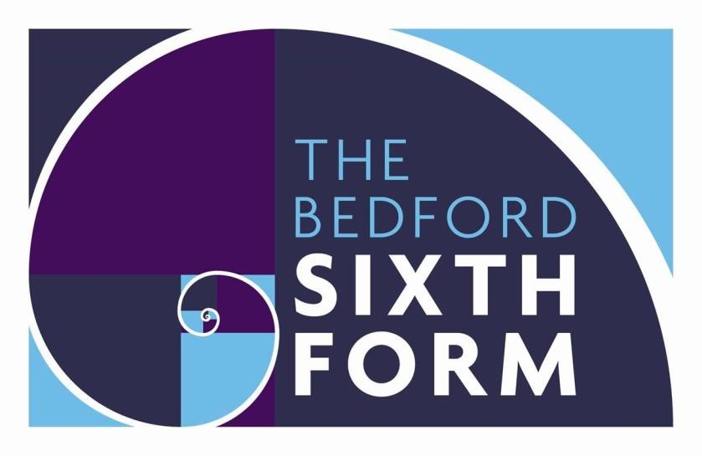

A level Film Studies – Student Support Pack 2022

Introduction
So you want to study film? This pack is designed to get you familiar with some of the approaches to studying films that we use at A-level. They include:
- Analysis of film form including:
  - Aesthetic
  - Narrative
- Exploration of a film’s context including:
  - Social
  - Political
  - Cultural
  - Historical
  - Institutional
To support your work through this booklet, you will need to access and watch the film High Maintenance by Phillip Van. At the time of writing, this is available at https://phillipvan.com/HIGH-MAINTENANCE .
The tasks you will work through in this booklet have been assigned points. As a minimum, you must complete tasks worth a combined 100 points. Your teacher will check the work you have done in your first lesson in September.

Before you watch the film, think briefly about what you expect from a short film. It is, after all, less than 9 minutes long. That’s pretty short.
Questions 1-3: 20 points
- Have you seen any short films before? If so, what were they? Where did you see them?
- What kind of story do you think can be conveyed in a film this short?
- As well as the limited length of the story, what other restrictions do you think a filmmaker might face trying to produce something so short?
Now watch the film.
Here is Phillip Van’s description of what the film is about:

It is about a woman who is dissatisfied with her monotonous marriage and decides to exchange her husband for an upgrade. In the near-future, husbands are modified and can be bought on the consumer market. The film uses hi-concept ideas to really focus on a small inner-personal story about a woman on her search for fulfillment through a man. Of course, it doesn’t turn out as she expected it to, and she has to deal with the consequences.

Questions 4-9: 30 points

- How often are films about having to ‘deal with the consequences’? Can you think of other examples?
Narrative is the word we use when we discuss how the story is told to us. In this case, the story begins without much happening. We just get to meet a couple in the middle of a meal.
- What was your impression of the couple? What were the clues that they were not functioning well together? Was it more to do with what they said or what they did?
It is typical for a film narrative to develop through three acts (parts). The turning point at the end of the first act is when the woman switches off the man.
- What do we discover at this moment? Would you call this a twist? How does it change the way you are watching the film?
The second turning point, at the end of act two, comes when the man switches off the woman.
- Was this also a twist? Were you surprised? Where there any clues that this was going to happen? When you watch it a second time, is there anything to give it away?
Often we like the end of a film to be tidy with no loose ends. We call this resolution or closure.
- Do you think this ending resolves the story? What is left to our imagination?
Aesthetic is the word we use to describe the ‘look’ or visual style of a film. As this entire film is set in only one location, the aesthetic is very strongly established through the setting.
- Choose 8 words to describe the ‘look’ of the film. To get you started, pick some from this list: clean/IKEA/modern/sophisticated/domestic
Aesthetic is also to do with the kind of technology used to make the film and how this influences what we see in the end result. For example, black and white film stock creates a very different aesthetic to full HD colour.

Films tell stories through a series of related shots. Editing is the process by which these shots are organised. This can include: the length of the shots, the order of the shots and how one shot transitions to the next (usually using a cut). When two shots

are put next to each other there is a meaning implied that the spectator is intended to interpret. Here is a simple example:

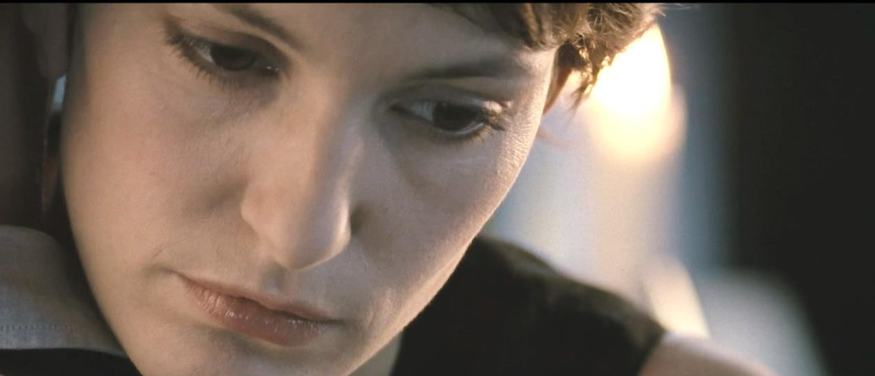
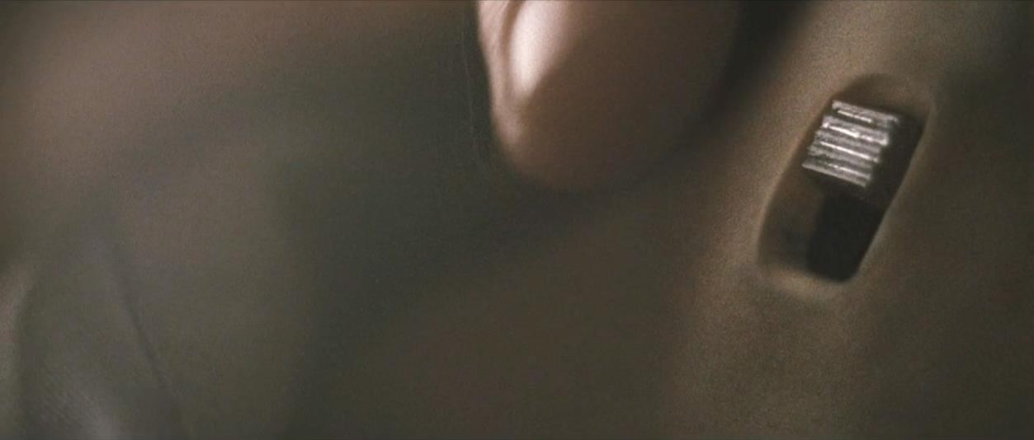

These two shots, placed next to each other, show us a neutral face followed by a switch being flicked. We don’t know what she is thinking, but we are encouraged to link her neutral face with the action that follows. Perhaps she is disappointed?
Resolved? Cruel? The point is that the editor has made the decision to put these shots next to each other to help tell the story. It is clear, at least, that it is the woman who is flicking the switch because it is her face that we see before the action.

10 points:
- Choose some more pairs of shots and decide what meaning is created by their relationship.
There are many ways to frame a shot. This process is called cinematography. The director and film crew will make careful decisions about what to include in each shot, what angle to position the camera and whether the camera should move at all.
The opening of the film is an over the shoulder mid-shot of the woman. I would suggest that, along with the objects placed on the table between the man and

women, this is to emphasise the distance between the couple. They are evidently not close in the frame and, by implication, in life either.
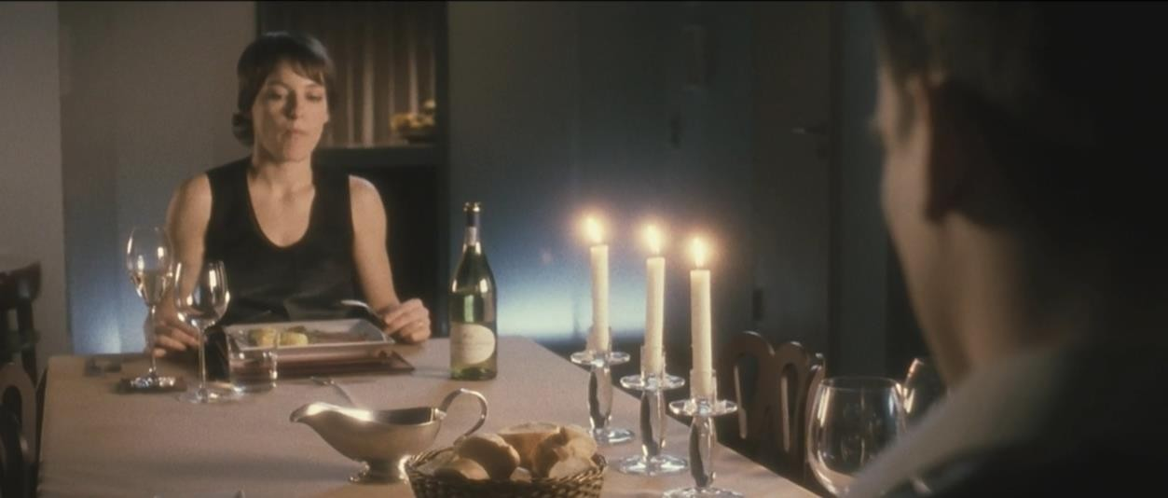
Mise-en-scene is the term we use to talk about all the props, costumes, actors and setting. Basically, this is everything that is placed in the scene. Set builders, artistic designers, props buyers, hair & makeup directors etc. all have an important input not just into the aesthetic of the film, but also the meaning. Look at the candles on the table. I would suggest that they are deliberately placed where they are to indicate the pretence of a romantic anniversary meal that is also a barrier between the couple.
10 points:
- Look at the four shots that follow. For each, jot down why you think the shot is framed the way it is. What meaning do you think is intended? Look also at the mise-en-scene. What props and elements of set can you see? What meanings do they bring to the film?
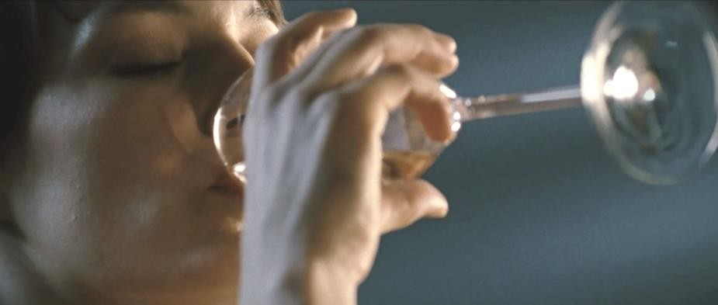
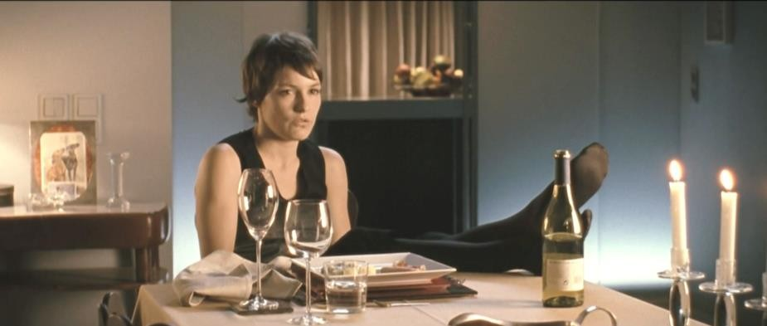

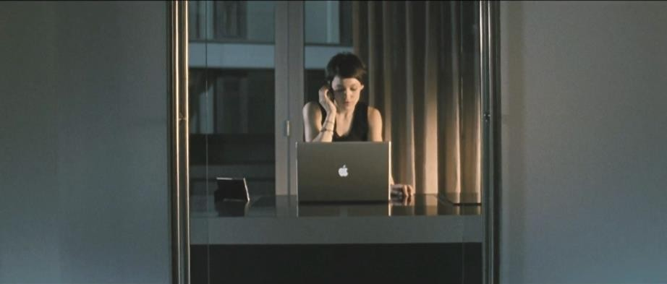
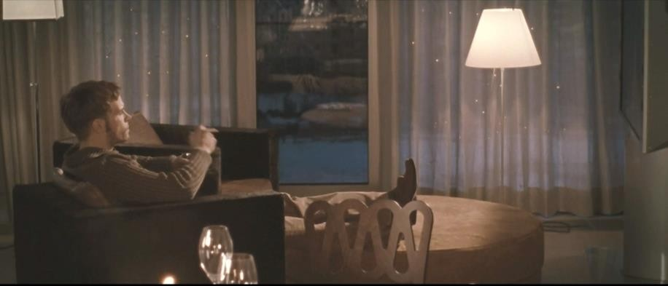
I find the sound in this film really interesting. Much of the tension comes from the silent room punctuated with the noise of the two people eating and drinking. Did you notice that the sound of these actions seems really loud? Partly this emphasises the tense silence between them, but I think it also draws our attention to the rituals of eating and drinking. These are a pair of androids acting out a human anniversary meal with mechanical attention to detail.
Sound that is exaggerated like this is called pleonastic sound.
10 points:
- Listen to the film with headphones on and turn away from the screen. What can you hear? Jot down some of the details.
The lighting in this film is also quite interesting, especially when you consider that it was shot entirely during daylight hours.
Here is an extract from an interview with Phillip Van discussing the lighting process:
Our location was on the 12th floor of an apartment building, and we had to shoot day for night. The whole story takes place at night. We were dealing with a full wall of windows in the living room, with no porch or access from the exterior. We put ND 1.2 gel on all these windows, but alone, it felt bland visually. We decided that if it was night and we were in a metropolis-based environment we should see building and city lights outside. We couldn’t get a crane to suspend a light outside the window, because we were too high and on a budget, and of course, none of the buildings were lit because it was the day.

I work as a DP in the city in addition to the work I direct, and my great DP, Felix

Novo De Oliveira and I collaborated pretty intensively on our lenses, f-stop, light units, all facets of photography before the shoot. We basically just used the simplest New York trick in the book – we strung up a set of Christmas lights behind the window sheers and in front of the ND, and then taped some of the bulbs to create different shapes with the light. By throwing the windows slightly out of focus in the background with longer lenses and an open f-stop, it looked convincingly like a city lit at night outside of the windows. It was a true no-cost solution and it was very effective.

In researching the look of the film, I decided that I wanted it to be softly lit but to have a high contrast ratio, with graphic lines and sharp, bold blacks. This dynamic aesthetic felt fundamentally related to the story, which I visually equate to an off- kilter mix between a romantic dinner, the film noir genre and a horror or scifi tale in a graphic novel. Soft light felt romantic, while dynamic contrast ratios came from the world of sci-fi and film noir and worked well with the uncanny and sometimes eerie tone of the film. The intermingling of the two was the way we married the visual world of the film with its narrative influences.

10 points:
- Watch back through some parts of the film looking in particular at the lighting. What impact does it bring to your experience? I like the way the faces have been lit in profile. Look at this example. This is what Phillip Van means about dynamic contrast ratio.

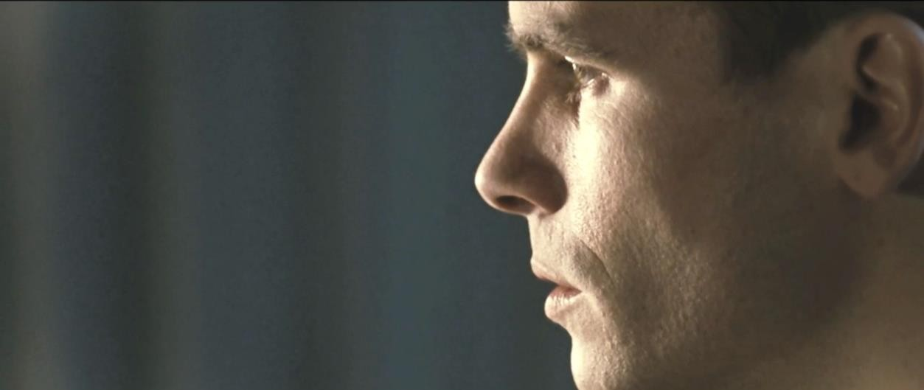

The context of this film is interesting. Philip Van was a film student studying in New York at the time he made the film. It was produced as a submission for a competition run by the Berlin International Film Festival.

10 points:
- Look up The International Berlin Film Festival – Berlinale. Find out what sort of festival it is, what kind of film categories it awards and some previous winners in some of these categories.

I made this film through the Berlin International Film Festival. Every year a student-oriented part of the festival called the Berlin Talent Campus admits around 500 filmmakers from approximately 3000 applicants based on their work. From the 500 filmmakers, three are selected to make short films during the week of the festival. The films are fully funded by a production company in Germany, and are made in a single week. The three films go into competition at the end of the festival and the 500 filmmakers in addition to industry guests vote on a
winner. It’s the largest jury vote in the Berlin film festival and this year my film,
“High Maintenance,” won the competition.
This tells us something about the production context of the film. It was made quickly and cheaply – not that this shows in the final produce. There are other ways of thinking about the context of a film. We can ask questions about what the film says about the world in which it was produced – the social and political concerns of that world.
10 points:
- What does High Maintenance say about the world we live in? Does it have a warning about our obsessions with technology? Does it say something about loneliness?
The film was made well before Covid-19 was a thing. Nonetheless, I can’t help watching it in the light of people’s experience of lockdown and how much more we have come to rely on technology for companionship and how much more we can order whatever we want online for delivery. The fact that the film’s narrative takes place entirely inside one apartment also implies a context that seems to be more relevant now than even when the film was made.
30 points:
- Have a go at writing your own idea for a short film. If you would like to try writing a proper looking screenplay, find out what the master scene script layout is and get a free account with WriterDuet to get started.

