Preparing for A level – Study Support Pack – Summer 2022

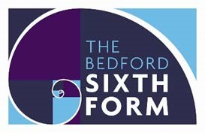
Subject:

The aim of this pack is to help you bridge the gap between GCSE and A level. It is specific to one of the many A level subjects that are taught at The Bedford Sixth
Form and we encourage you to work through all the relevant packs for the subjects that you would like to study.
www.bedfordsixthform.ac.uk

Welcome to
English Literature
Within this pack you will find specific areas of research to aid your knowledge and help develop some key skill requirements, expanding your knowledge of literature and enhancing your overall learning experience in college.
Due to recent events some of the tasks revisit a few of the core areas you have studied at GCSE to help you refocus your skills and knowledge.
The research can be completed via internet or books. A lot of the earlier literature can be downloaded free. When the libraries are reopened all of the text are available in the libraries.
Do not rush through the tasks. Take your time to learn the researched information. Take notes and collect information. Save your notes into a folder, you will be able to use them during the year.
The tasks in this booklet are worth points. You must complete tasks worth a minimum of 100 points in total. Your teacher will check the work you have done in your first lesson in September.
Task 1 Building a glossary. Poetry
Find the definition and example for each of these literary techniques. (10 points)
Literary technique | Definition | Example
Personification
anaphora
Alliteration
Allegory
colloquialism
Euphemism
Foreshadowing
Hypophora
Hyperbole
connotation
Palindrome
Assonance
Synesthesia
Aposiopesis
Double Entendre
Hyperbaton
Hubris
Adjacency pair
Contrastive pair
Semantic Field
Superlative
Task 2a. Identifying Poem types. Write an explanation of each of these poetry types. (10 points)
Poetry type | Explanation of Poetry type
Dramatic Monologue
Ballard
Blank Verse
Limerick
Haiku
Pastoral
Italian Sonnet
Tanka
Cinquain.
Sestina
Shakespearian Sonnet

Task 2b Identifying Poems continued. Identify these different types of poems.
When I Consider How My Light Is Spent
Watermelon
When I consider how my light is spent
Watermelon Ere half my days, in this dark world and wide,
Juicy, sweet And that one talent which is death to hide
Lodged with me useless, though my soul more
Dripping, slurping, smacking bent
To serve therewith my Maker, and present
So messy to eat My true account, lest he returning chide;
Yummy "Doth God exact day-labor, light denied?"
I fondly ask; but Patience to prevent
Coming to a wall, That murmur, soon replies, "God doth not need
The Passionate Shepherd to His Love
BY CHRISTOPHER MARLOWE
1.Come live with me and be my love,
And we will all the pleasures prove,
That Valleys, groves, hills, and fields,
Woods, or steepy mountain yields.
2.And we will sit upon the Rocks,
Seeing the Shepherds feed their flocks,
By shallow Rivers to whose falls
Melodious birds sing Madrigals.
3.And I will make thee beds of Roses
And a thousand fragrant posies,
A cap of flowers, and a kirtle
Embroidered all with leaves of Myrtle;
4.A gown made of the finest wool
Which from our pretty Lambs we pull;
Fair lined slippers for the cold,
With buckles of the purest gold;
5.A belt of straw and Ivy buds,
With Coral clasps and Amber studs: And if these pleasures may thee move,
Come live with me, and be my love.
6.The Shepherds’ Swains shall dance and sing
For thy delight each May-morning:
If these delights thy mind may move,
Then live with me, and be my love
a lacewing Mayfly Either man's work or his own gifts; who best
Bear his mild yoke, they serve him best. His state
is clinging to it -- Is kingly. Thousands at his bidding speed
And post o'er land and ocean without rest:
the sheer transparency They also serve who only stand and wait."
Of the wings, their mournfulness
John Milton
The sea was not a mask. No more was she.
The song and water were not medleyed sound Even if what she sang was what she heard, Since what she sang was uttered word by word.
It may be that in all her phrases stirred
The grinding water and the gasping wind; But it was she and not the sea we heard.

Task 3: Read through and analyse the poem. Identify the: Theme, Literary techniques, type of poem, and speaker. (20 points)
Arms and the Boy
BY WILFRED OWEN

Let the boy try along this bayonet-blade How cold steel is, and keen with hunger of blood;
Blue with all malice, like a madman's flash; And thinly drawn with famishing for flesh.

Lend him to stroke these blind, blunt bullet-leads,
Which long to nuzzle in the hearts of lads, Or give him cartridges of fine zinc teeth Sharp with the sharpness of grief and death.

For his teeth seem for laughing round an apple.
There lurk no claws behind his fingers supple;
And God will grow no talons at his heels, Nor antlers through the thickness of his curls.

Task 4a: Select one female and one male poet from the selection below, and research their lives and their poems.
(10 points)
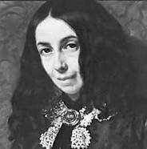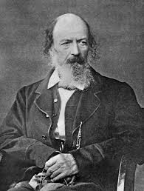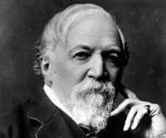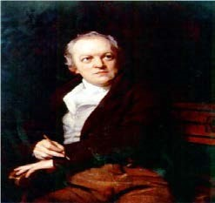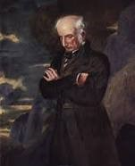

Elizabeth Barrett Browning Alfred Tennyson Robert Browning William Blake William Wordsworth
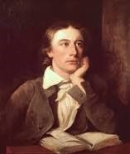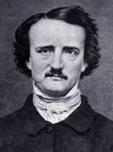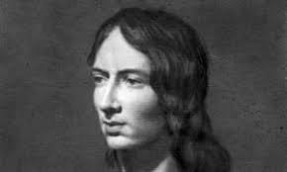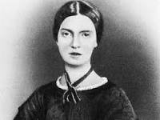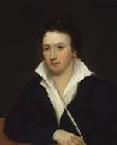

John Keats Edgar Allen Poe Emily Bronte Emily Dickenson Percy Bysshe Shelley

Task 4b. Select a poem from each of your chosen poets and analyse the poems; looking at theme, literary techniques, speaker and structure. Reading any of the above poets work, would greatly improve you breadth of knowledge in Victorian literature. (20 points)

Task 5a American Literature.
Words that differ from Standard English. Give the Standard English example. (10 points)
American English | Standard English
American antenna aluminum counterclockwise Period (punctuation) check gray maneuver meter plow
program skeptical toward
transportation tire
respectfully yours / yours truly
sincerely yours Color

Task 5b
Write a brief diary entry as an American using American English. You can go on-line and find other Americanisms to include in your diary entry. (20 points)

Diary Entry.

Task 6 Read the following extract and consider how the writer is conveying meaning. How does the writer describe the setting? Can you identify any literary techniques? What can you infer about the narrative from this extract? (30 points)
I24 WAS SPITEFUL. Full of a baby's venom. The women in the house knew it and so did the children. For years each put up with the spite in his own way, but by 1873 Sethe and her daughter Denver were its only victims. The grandmother, Baby Suggs, was dead, and the sons, Howard and Buglar, had run away by the time they were thirteen years old--as soon as merely looking in a mirror shattered it (that was the signal for Buglar); as soon as two tiny hand prints appeared in the cake (that was it for  Howard). Neither boy waited to see more; another kettleful of chickpeas smoking in a heap on the floor; soda crackers crumbled and strewn in a line next to the doorsill. Nor did they wait for one of the relief periods: the weeks, months even, when nothing was disturbed. No. Each one fled at once--the moment the house committed what was for him the one insult not to be borne or witnessed a second time. Within two months, in the dead of winter, leaving their grandmother, Baby Suggs; Sethe, their mother; and their little sister, Denver, all by themselves in the gray and white house on Bluestone Road. It didn't have a number then, because Cincinnati didn't stretch that far. In fact, Ohio had been calling itself a state only seventy years when first one brother and then the next stuffed quilt packing into his hat, snatched up his shoes, and crept away from the lively spite the house felt for them.  Baby Suggs didn't even raise her head. From her sickbed she heard them go but that wasn't the reason she lay still. It was a wonder to her that her grandsons had taken so long to realize that every house wasn't like the one on Bluestone Road. Suspended between the nastiness of life and the meanness of the dead, she couldn't get interested in leaving life or living it, let alone the fright of two creeping-off boys. | Her past had been like her present--intolerable--and since she knew death was anything but forgetfulness, she used the little energy left her for pondering color."Bring a little lavender in, if you got any. Pink, if you don't."  And Sethe would oblige her with anything from fabric to her own tongue. Winter in Ohio was especially rough if you had an appetite for color. Sky provided the only drama, and counting on a Cincinnati horizon for life's principal joy was reckless indeed. So Sethe and the girl Denver did what they could, and what the house permitted, for her. Together they waged a perfunctory battle against the outrageous behavior of that place; against turned-over slop jars, smacks on the behind, and gusts of sour air. For they understood the source of the outrage as well as they knew the source of light.  Baby Suggs died shortly after the brothers left, with no interest whatsoever in their leave-taking or hers, and right afterward Sethe and Denver decided to end the persecution by calling forth the ghost that tried them so. Perhaps a conversation, they thought, an exchange of views or something would help. So they held hands and said, "Come on.  Come on. You may as well just come on."  The sideboard took a step forward but nothing else did.  "Grandma Baby must be stopping it," said Denver. She was ten and still mad at Baby Suggs for dying.  Sethe opened her eyes. "I doubt that," she said.  "Then why don't it come?"  "You forgetting how little it is," said her mother. "She wasn't even two years old when she died. Too little to understand. Too little to talk much even."

Task 7 American Authors:
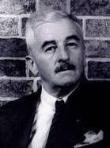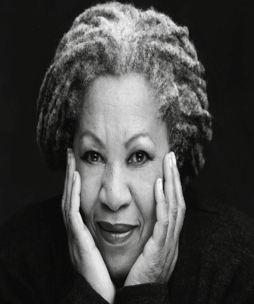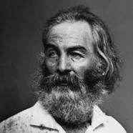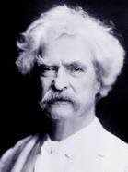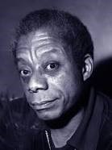

William Faulkner Toni Morrison Walt Whitman Mark Twain James Baldwin
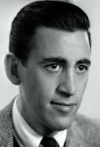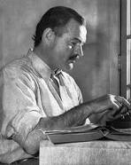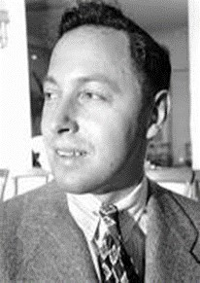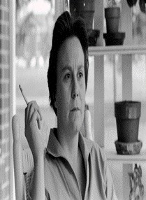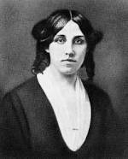

J D Salinger Earnest Hemmingway Tennessee Williams Harper Lee Louisa May Alcott

Research the authors above and identify the work they are most famously identified with.
Reading any of their works would expand your breadth of knowledge in American literature. (10 points)

Task 8: American History Timeline (20 points)
Research American Events in History which you feel have had significant literary influence on American writers. Complete a time line with a brief outline of four significant events and the way in which an author may have been influence. Connect to a significant piece of work if you can.
Event and Date

Author

----------------------------------- -------------------------------------- -------------------------------------- -----------------------------------
Connected literary work

Task 9 Shakespeare. (10 points)
Mind map everything you already know about Shakespeare.

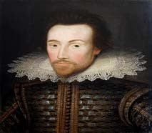

Task 10 Can you answers these? (10 points)
Shakespeare Plays Trivia
- Where was Shakespeare born?
- What was the name of Shakespeare’s wife? (Hint: She shares a name with the Actress who plays Viola in the New York Shakespeare Festival’s 2009 production of Twelfth Night.)
- How many sonnets did Shakespeare write?
- How many times does suicide occur in Shakespeare’s plays?
- What is the name of Shakespeare’s theatre?
- Where is Shakespeare buried?
- Which of Shakespeare’s plays is the shortest?
- Which of Shakespeare’s plays is the longest?
- Which two Shakespeare plays are written entirely in verse?
- Which two Shakespeare plays are translated into Klingon?
- Which of Shakespeare’s plays is responsible for starlings being released into North America?
Identify the plays from these quotes. (20 points)
- “Cowards die many times before their deaths; The valiant never taste of death but once.”
- “Be not afraid of greatness. Some are born great, some achieve greatness, and others have greatness thrust upon them.”
- “All the world’s a stage, and all the men and women merely players.”
- “If you prick us do we not bleed? If you tickle us do we not laugh? If you poisonus do we not die? And if you wrong us shall we not revenge?”
- “If music be the food of love, play on.”
- “All that glisters is not gold.”
- “The course of true love never did run smooth.”
- “Uneasy lies the head that wears the crown.”
- “To thine own self be true.”
- “The fool doth think he is wise, but the wise man knows himself to be a fool.”
- “All the perfumes of Arabia will not sweeten this little hand.”
Shakespeare Film Trivia ( 10 points)
- What actor played King Henry in the 1989 Henry V?
- Which 1995 film adaptation featured Laurence Fishburne in the titular role?
- Which Shakespeare film adaptation was directed by Joss Whedon?
- Which Shakespeare film adaptation is a modernization of The Taming of the Shrew?
- The 2006 romantic comedy She’s the Man is based on what Shakespeare play?
- Which Disney film is a based on Romeo and Juliet?
- What 1994 film featured the song “Hamlet Rap” performed by the Double D’s?

Task 11: Key terms needed when analysing Shakespeare language.

1. Allusion
This is a reference to a person, place, event, usually without explicit identification. Allusions can be references to mythology, the bible, historical events, geography, legends, or other literary works. Authors often use allusion to establish a tone, create an implied association, contrast two objects or people, make an unusual juxtaposition of references, or bring the reader into a world of experience outside the limitations of the story itself. Biblical references are common in literary works of all periods. Shakespeare’s plots are frequently based on legends and historical events, which are also merely referred to in other plays. Shakespeare was fond of alluding to mythology and one of his most effective uses of that is in Antony and Cleopatra where the earthly lovers are frequently described in terms of Roman gods. In that play the lovers transcend the limits of ordinary earthly romantic love, and the imagery reflects and illuminates that idea.

2. Dramatic Device
Dramatic devices were not invented by Shakespeare as a drama would not hold up without them: the plays of Shakespeare’s predecessors and contemporaries used them, but one of the reasons that Shakespeare’s plays are so gripping and suspenseful is that he was a master of the dramatic device. A dramatic device is anything that drives the action. In Shakespeare’s plays they come one after another, each one following closely on the previous one. In Macbeth, for example, the witches plant the idea of becoming king in Macbeth’s mind, which leads him to raise it with his wife, who encourages him to kill Duncan, which he does. There are two dramatic devices for a start. Duncan’s arrival at Glamys is another. And then comes the murder of Duncan, an enormous dramatic device, which creates all kinds of movement. And so it goes on, one after another, each one the result of the previous one, hurling the action forward, until the last moment of the drama.

3. Dramatic Irony
Dramatic irony is a situation in which the reader knows something about present or future circumstances that the character does not know. For example, in Macbeth, when Duncan’s murdered body is found Macbeth behaves as though he’s angry with the supposed murderers but the audience knows that he is in fact the murderer. That’s dramatic irony.

4. Monologue
Shakespeare’s plays are strewn with monologues – a long, uninterrupted speech that is spoken in the presence of other characters. Unlike a soliloquy a monologue is heard by other characters.

5. Soliloquy
A speech in which a character, who is usually alone on the stage, expresses his or her thoughts aloud. It is a very useful device, as it allows the writer to convey a character’s most intimate thoughts and feelings directly to the audience. The convention is that the audience is allowed to hear the character’s thoughts. He or she is not talking, but thinking. Shakespeare uses soliloquies liberally, and some of his finest pieces of writing are in this form, for example the ‘To be or not to be’ soliloquy in Hamlet.

6. Symbolism
Shakespeare’s use of symbolism is one of his strongest, most distinguishing characteristic. It is the frequent use of words, places, characters, or objects that mean something beyond what they are on a literal level. If, for example, a writer uses the word ‘blood’ once its meaning will be confined to that instance in which it is used. But if the word is used repeatedly, as it is in plays like Macbeth and Romeo and Juliet it expresses some profound ideas. By using a word repeatedly in different contexts it expresses several interlocking themes. In Romeo and Juliet ‘blood’ refers to all the following and more themes: violence, youth, passion, family ties. In King Lear this technique is particularly well developed. One strand of imagery refers to wild animals with sharp teeth, talons and claws, reflecting the savage and cruel way the members of the younger generation treat their elders, and giving clear images of the pain suffered by Lear and Gloucester.

7. Metaphors
A Metaphor is a figure of speech that makes an implicit, implied, or hidden comparison between two things that are unrelated, but which share some common characteristics. In other words, a resemblance of two contradictory or different objects is made based on a single or some common characteristics.

8. Similes
A simile is a figure of speech that makes a comparison, showing similarities between two different things. Unlike a metaphor, a simile draws resemblance with the help of the words “like” or “as.” Therefore, it is a direct comparison
9. Rhyming couplets.
A couplet is a literary device that can be defined as having two successive rhyming lines in a verse, and has the same meter to form a complete thought. It is marked by a usual rhythm, rhyme scheme, and incorporation of specific utterances.
10. Prose and verse.
Prose is the form of writing that we most commonly use in speech with each other. Prose is the term for any sustained piece of text that does not have a consistent rhythm. Verse is different: verse has a set rhythm (or meter), and it looks distinctive on the page as the lines are usually shorter than prose.

Task 12: Read through this extract. Can you identify any of the techniques? Can you identify

which of Shakespeare’s plays this is? (10 points)
[Enter DUKE ORSINO, CURIO, and other Lords; Musicians attending]
- Orsino. If music be the food of love, play on; Give me excess of it, that, surfeiting, The appetite may sicken, and so die.
That strain again! it had a dying fall:5
O, it came o'er my ear like the sweet sound, That breathes upon a bank of violets,
Stealing and giving odour! Enough; no more:
'Tis not so sweet now as it was before.
O spirit of love! how quick and fresh art thou,10
That, notwithstanding thy capacity
Receiveth as the sea, nought enters there,
Of what validity and pitch soe'er,
But falls into abatement and low price, Even in a minute: so full of shapes is fancy15 That it alone is high fantastical.
- Curio. Will you go hunt, my lord?
- Orsino. What, Curio?
- Curio. The hart.
- Orsino. Why, so I do, the noblest that I have:20 O, when mine eyes did see Olivia first,
Methought she purged the air of pestilence!
That instant was I turn'd into a hart;

- And my desires, like fell and cruel hounds,
- E'er since pursue me.25 [Enter VALENTINE] How now! what news from her?
- Valentine. So please my lord, I might not be admitted; But from her handmaid do return this answer:
The element itself, till seven years' heat,30
Shall not behold her face at ample view;
But, like a cloistress, she will veiled walk
And water once a day her chamber round
With eye-offending brine: all this to season A brother's dead love, which she would keep fresh35 And lasting in her sad remembrance.
- Orsino. O, she that hath a heart of that fine frame To pay this debt of love but to a brother,
How will she love, when the rich golden shaft
Hath kill'd the flock of all affections else40
That live in her; when liver, brain and heart,
These sovereign thrones, are all supplied, and fill'd Her sweet perfections with one self king!
Away before me to sweet beds of flowers:
Love-thoughts lie rich when canopied with bowers.45
[Exeunt]

Task 13.
Essay writing is a key skill requirement for AS and A’level English.
See the links below to help develop your essay writing skills.
https://www.oxbridgeessays.com/blog/essay-writing-tips/ https://www.oxford-royale.com/articles/tips-techniques-essay-writer/#aId=895df400-9d18-4ac4-8e30-1d8e09f6f3c2 https://www.scribbr.com/category/academic-essay/
Independent research is also a key skill requirement, see the links to help to research effectively.
https://www.howtogeek.com/400110/how-to-research-a-topic-online/ https://www.onlineuniversities.com/articles/students/how-to-begin-basic-academic-research/
Reading around the area of study is one of the best ways to improve your understanding, academic confidence and ability within the subject. All of the tasks in this pack have given you areas to research. Reading text by authors who published around the same time or were influential to the author being studied helps to develop social, historical and cultural awareness: a dominant assessment area within the subject specification.
Victorian literature: Gothic, Romantics and some Greek classic knowledge would be helpful.
American Literature: American history, especially 1900’s and reading different authors listed in this pack would be beneficial.
Shakespeare: Examining other play writers of the era; Christopher Marlow, Ben Johnson would help to develop your knowledge of the language. Researching the Play scene during the Elizabethan era would also help. The Royal Shakespeare Company have televised several of
Shakespeare’s plays, an excellent way to familiarise yourself with the Bard. https://www.rsc.org.uk/news/watch-rsc-shows-from-home

Notes:

