Preparing for A Level – Study Support Pack: Summer 2022
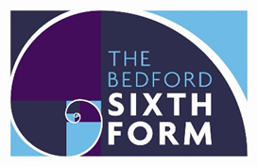

Subject: English Language

The aim of this pack is to help you bridge the gap between GCSE and A level. It is specific to one of the many A level subjects that are taught at The Bedford Sixth Form and we encourage you to work through all the relevant packs for the subjects that you would like to study.

www.bedfordsixthform.ac.uk

A Level English Language Year 11 Bridging the Gap

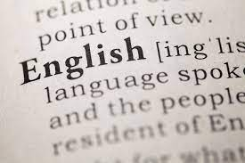

Welcome, year 11! This is your ‘Bridging the Gap’ booklet for English Language, which you’ve chosen to take at the Sixth Form this September. The pack is designed to give you a flavour of what A Level English Language is all about. The pack will introduce you to some of the key terms and ideas surrounding the course. The work in these packs will take a long time, so you can break it up. Don’t feel you need to complete it all in one go! You can complete the tasks in this booklet in the spaces provided.
Tasks in the booklet have been assigned points, which you will gain as you complete tasks. You must complete all the tasks to gain 100 points. Your teacher will check the work you have done in your first lesson in September.

Useful Resources
One of the most important and overlooked things any student can do is to simply watch and read around their subject. This is something that will be drilled into you from day one until the day you leave.

Below there will be a list of useful books. Podcasts and websites

Books:
Any book you want. Just make sure you read!

Podcasts:
Something Rhymes with Purple: https://play.acast.com/s/somethingrhymeswithpurple
The Allusionist: https://www.theallusionist.org/

Websites:
http://www.englishbiz.co.uk/mainguides/a-level_frameworks.htm
http://www.universalteacher.org.uk/
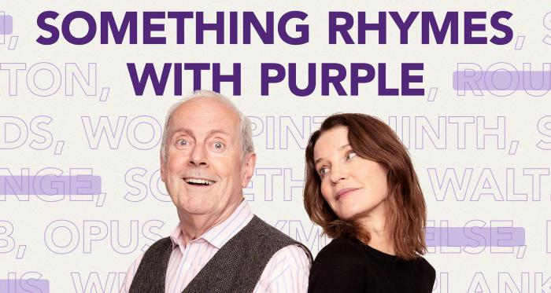

Task One: Countdown
10 points
Find the most words you can and the longest word you can!

Interesting fact on the last page
Task Two: Introductory Quiz
Read the following and note down the words they define

20 points

1. The vocabulary of a language; the total stock of words and idiomatic combinations of them in a language
2. The study of meaning
3. The way the sentences of a language are constructed
4. The patterns of speech sounds in a language and the tacit rules governing pronunciation
5. Any unit of connected speech or writing longer than a sentence
6. A person's individual speech pattern
7. An uninterrupted segment of speech consisting of a vowel sound, a diphthong, or a syllabic consonant
8. A word or notion having an actual or existent thing or instance as its referent
9. An idea or term considered apart from some material basis or object.
10. Words that modify nouns and pronouns, primarily by describing a particular quality of the word they are modifying
11. Words that express action, state, or a relation between two things

Answers on the last page
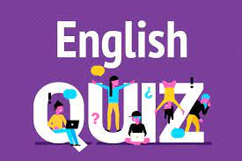

Task Three: What’s the Etymology?
20 points

Etymology is the origin of words. There are a number of really interesting and funny ones. Research the etymology for the words below. I have left space for you to find one of your own. The funniest wins

Word/phrase | Etymology
Avocado
Lick into shape
Swan-song

Idiolect Investigation

Your language didn’t arise out of thin air.

Although humans appear to be born with some readiness to learn language, the type of language we learn is influenced by our environment. All the people we interact with as we grow up influence the language that we use, even if we remain in one place all the time and the language that we hear has only very small variations. Your family can have an interesting language history if you have lived in Bedford or Luton all your lives.

Your own language is unique, like fingerprints. It has many characteristics, ranging from accent and voice quality to typical gestures and much used phrases.

Idiolect is your own personal dialect.

Idiolect
The stem of the word derives from the Greek word idios , which means one’s own.
Idiolect is your personal language habit that gives every individual his/her personal style of language use. What contributes to such individual style are the following:
- tone of voice: high/low pitch - hard / soft - loud / quiet
- favoured choice of words / phrases
- lexis: long, unfamiliar words or simple, everyday words
- silence fillers: erm, well, mmh....
- eye contact / gestures - how frequent?
- conversational moves:
  - ask questions,
  - give orders,
  - exclaim,
  - initiate,
  - interrupt
- Style: range from formal to informal, from humorous to serious
- sentence: long, short

Task Four: Idiolect
20 points
Think about the following and make some notes

- Your early language history – can you remember learning to speak, ask your parents what your first words were.
- Comment on your family history and what influence this might have been on your own language learning.
- What other influences have there been in your life e.g. have you moved countries?
- How do you think your friends influence the way that you speak?
- Look at your written repertoire – what sorts of writing / reading do you prefer? Can you hypothesise about why this might be?
- Are there any particular words that you use that you know you have picked up from your friends or your normal social groups?
- When was the first time that you realised that you had an accent or a dialect? What do you think of your idiolect? Are you happy with the way that you sound? Or would you like to change your accent?

Task Five: Analysis Practise
30 points
Use the terms that you have found from your quiz to find examples of them in the text below.
What other things can you spot in this that you have learnt previously?

Stretch: don’t just spot what is there, but think about its effect on the audience – why is it there and what does it do?

Answer Page

Task One: Countdown

Did you find the word ‘cryptoscopophilia’? If so, well done. Even if you didn’t I’m sure you have all suffered from it. It is the urge to secretly look through windows of homes as you pass by.

Task Two: Introductory Quiz

Lexis
semantics
grammar
phonology
discourse
dialect
syllable
concrete nouns
abstract nouns
adjectives
verbs

