A LEVEL DANCE
Support work book
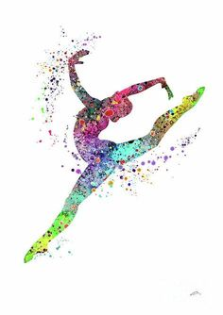

Welcome to the Bedford Sixth Form A Level Dance course.
This work book is intended to support you prior to the beginning of your academic course in September 2022.
There are four areas which we would like you to complete along with ‘getting to know you’ questions which are optional. The four areas reflect the ethos and course content and ways in which you will be expected to engage with the subject area. When you start the course you will be engaged in practical workshops and technique classes in the dance studio and theatre space.

Getting to Know You (optional)

Why do you like to dance?

What music inspires you to dance?

What do you hope to do in your working life?

Are there any choreographers or dance works you particularly like?

Favourite film (not necessarily dance related).

Hobbies/interests

Anything else you want to add

AREA ONE: THE HEALTHY DANCER (25 marks)

Task One: Decide how important each of the following aspects are to keeping the body and mind healthy when studying dance. Score one to ten for each aspect (ten being very important and one being not important at all).

Appropriate warm-up and cool-down _______

Positive Body Image _______

Understanding of correct alignment and posture _______

Healthy and balanced meals _______

Good relationships with other dancers/tutor _______

Task Two:
Choose one aspect of the above to research and produce a hand-out which will be useful for all group members. Include in the hand-out
- Identification of the aspect and why you think it is important
- How this aspect impacts on the development of dance training
- Examples of ways which you can implement a plan to ensure that the aspect you have chosen is addressed

AREA TWO: RAMBERT DANCE (25 marks)

Task One: Research Rambert Dance website. Read the ABOUT section and answer the following questions.
- Who founded Rambert Dance Company?

- Which year was their first performance?

- What changes were made to the company in 1966?

- Name two Artistic Directors of the company from 1966 onwards and what was their vision for the company?

Task Two: Watch a dance clip by Christopher Bruce on you tube (make sure it is danced by a professional company) and discuss your response. Consider the following:-
- Did you like or dislike the dance?
- What did you like/dislike about the piece (music, movement vocabulary, theme, set, costume, choreographic devices).
- Why do you think Bruce was a successful choreographer?

AREA THREE: CHOREOGRAPHY (25 marks)

Choose one of the three art pieces as stimulus you could use for a dance piece.

- Robert Mapplethorpe Photography

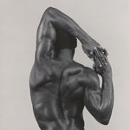

2. Jackson Pollock Artist
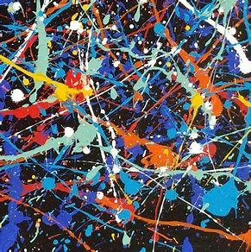

3. Tracey Emin – conceptual art
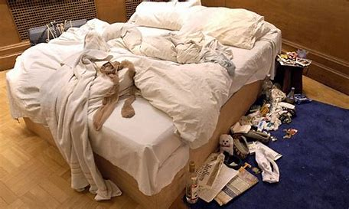

Task One:

Explore the possibilities of movement and create a short phrase in response to the piece. Whilst exploring, consider
- How does the piece make you feel; what emotions does it bring out?
- The shape and form of the art work and how you could explore movement ideas around these, for example:- lines, shapes, light, shadow within the art piece that can be transferred to the body in motion
- The intention of the piece (your interpretation).
- What can you say about the piece through movement.

Task Two:
Describe your phrase. What music could you use to highlight the artistic intention? What costume could you use? What ideas have you got regarding lighting?

AREA FOUR: AMERICAN MODERN DANCE (25 marks)

You may need to access the internet to find the answers:
Quiz:-

- Marie Rambert, the founder of Rambert Dance was heavily influenced by Isadora Duncan. Who was Isadora Duncan and what was she famous for?

- Why do you think that the American modern dance movement began. What was it a reaction against?

- There were three main pioneers of the American Modern Dance movement, one is Isadora Duncan, who were the other two?

- Martha Graham was part of the second wave of the American Modern Dance movement. One of the main contributions Martha Graham made was to develop a contemporary dance technique that was completely unique and divorced from classical ballet. What are the main stylistic characteristics of this technique?

- Can you name three dance works by Martha Graham and identify the themes?

THE END
We are looking forward to welcoming you to the Sixth Form in September 2022.

