A-level Computer Science Work Pack
Michael Yates myates@bedfordsixthform.ac.uk
Kris Li kli@bedfordsixthform.ac.uk

Coding challenges (100 points total)
Please email your work to myates@bedfordsixthform.ac.uk. Attach your .py files on your email.
The coding challenges below will let you check your skills and give you further practice. Part of the transition to A-level is combining skills, and also ensuring that you plan and test your work thoroughly. Think about how you can re-use components and design your code for readability and robustness.
With all the challenges, plan your algorithm first, using a flowchart or pseudocode. Code your algorithm, and provide evidence of both your code and the working output. Create a test plan for your algorithm, including testing your validation with normal, boundary and erroneous data.

Part 1 - (10 points)
Write a program to:
a) Ask the user to input
i. Their first name
ii. Their surname
iii. A date, in the format DD/MM/YYYY
b) The program should then output a customer ID as follows:
i. The date in the format YYYYMMDD, then the first three letters of the surname, then the first initial, then the length of their first name. All letters should be in capitals
ii. For example, John Smith, 27/05/2017 would give 20170527SMITHJ4
c) The program should validate any inputs and keep asking for inputs until the user enters correct details or types “quit” at any point
Part 2 - (30 points)
Write a program to:
a) Ask the user to input
i. The name of a product ii. Its cost in pounds
iii. The program should keep asking for inputs until the user types “None”
b) The program should then output:
i. The name and price of the most expensive item
ii. The name and price of the least expensive item
iii. The average price of the items
iv. The total cost of the items
- Items over £50 get a 5% discount - VAT is added at the end at 20%
c) The program should validate any inputs

Part 3 - (30 points)
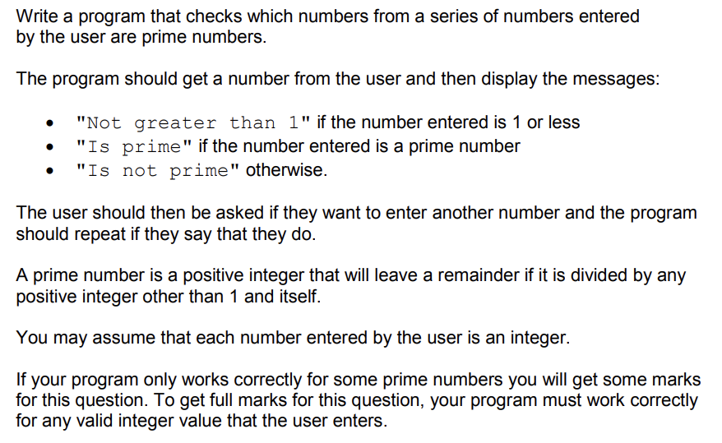

Part 4 – (30 points)
