Preparing for A level – Study Support Pack – Summer 2022

Subject: Biology A Level

The aim of this pack is to help you bridge the gap between GCSE and A level. It is specific to one of the many A level subjects that are taught at The Bedford Sixth Form and we encourage you to work through all the relevant packs for the subjects that you would like to study.

Look for the number of points each task is worth – you need to complete a total of at least 100 points worth

www.bedfordsixthform.ac.uk

Task 1: Double science catch-up (Compulsory for double science, optional for triple) – This task is worth 30 points
A common worry amongst students is that if you did double science at GCSE (as opposed to triple science, where you study biology, chemistry and physics individually) that you will be at a disadvantage. Whilst it is not essential to have studied triple science, it is certainly useful, as there are some topics that you will have covered that are not covered in double science.
If you did double science at GCSE, then this task is compulsory, so that you are not at a disadvantage in September. If you did triple science, then this is optional (but why not test your memory!)
TASK: Read the following pages on BBC bitesize (type the heading into google or follow hyperlink). Make summary notes on each. Bring these notes to the first lesson and keep them safe, as many of these topics will come up over the next two years! You can also try the questions on bitesize for each:
- Treating, curing and preventing disease: https://www.bbc.co.uk/bitesize/guides/z8fkmsg/revision/5
- Monoclonal antibodies: https://www.bbc.co.uk/bitesize/guides/zt8t3k7/revision/1
- Plant disease: https://www.bbc.com/bitesize/guides/z3tgw6f/revision/2
- Coordination and control: https://www.bbc.co.uk/bitesize/guides/zprxy4j/revision/3
- Homeostasis in humans: https://www.bbc.com/bitesize/guides/zxgmfcw/revision/1
- Plant hormones: https://www.bbc.co.uk/bitesize/guides/zc6cqhv/revision/1
- Reproduction, the genome and gene expression: https://www.bbc.co.uk/bitesize/guides/z9pkmsg/revision/1
- Evolution: https://www.bbc.co.uk/bitesize/guides/zcqbdxs/revision/1
- Genetic inheritance: https://www.bbc.co.uk/bitesize/guides/zg8f4qt/revision/1
- Decomposition: https://www.bbc.co.uk/bitesize/guides/zy7gw6f/revision/1
- Biodiversity: https://www.bbc.co.uk/bitesize/guides/zt8f4qt/revision/1
- Trophic levels in an ecosystem: https://www.bbc.co.uk/bitesize/guides/zs7gw6f/revision/2
- Food production: https://www.bbc.co.uk/bitesize/guides/ztwvk2p/revision/1

Task 2: Biology prefixes and suffixes – This task is worth 20 points
The A level biology course has a wide range of vocabulary that you need to understand and be able to use in exam answers. Knowing and spotting prefixes (bits that come at the start of words) and suffixes (bits that come at the end of words) is an incredibly useful tool for working out what biological words mean.
TASK: Fill in the table below with what each prefix and suffix means and find one biological example of each. Some you may know, others you will need to research!
Prefix/suffix | Meaning/what it refers to | Example
glyco-
gluco-
plasmo-
anti-
cyto-
hyper-
hypo-
phago-
eu-
hydro-
exo-
endo-
-kinesis
-cytosis
-cyte
-gen
-tonic
-lysis
-phase
-some
-karyotic
-plast

Using what you have found out, try to deduce the meaning of these biological terms:
- Glycogenesis (glyco-genesis) = _________________________________

- Phagocyte (phago-cyte) = ____________________________________

- Exocytosis (exo-cytosis) = __________________________________

- Eukaryotic (eu-karyotic) = __________________________________

- Hypotonic (hypo-tonic) = ____________________________________

- Gluconeogenesis (gluco-neo-genesis) = __________________________________

- Hydrolysis (hydro-lysis) = ___________________________________

- Cytokinesis (cyto-kinesis) = ___________________________________

Task 3: Maths & data skills in biology – This task is worth 30 points
Maths is an important part of the biology A-level that will always be tested in the exams.
You may have carried out a practical investigation in the past, during which you calculated your heart rate by taking your pulse. Heart rate can be used to calculate cardiac output – provided that you have a value for the individuals’ stroke volume – using the equation:
cardiac output = heart rate x stroke volume

TASK: Answer the following questions
- Define the terms ‘cardiac output’ and ‘stroke volume’ (you may need to use the Internet or other research to help you).

- Cardiac output is measured in cm3min-1 (cm3/min). Heart rate is measured in beats per minute. Suggest what units stroke volume is measured in.

- Rearrange the equation so that stroke volume is the subject of the equation. Use your rearranged equation to calculate the athlete’s stroke volume after training, using the data below:
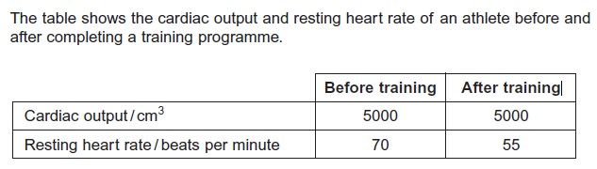

- Using the data above, calculate the percentage decrease in the athlete’s resting heart rate after training.

- As well as the heart rate, breathing rate also increases during and following exercise. What units are used to express breathing rate?

- Measure your breathing rate at rest five times. Calculate the mean, median and mode of your data. Extension: Can you also define and calculate standard deviation?

- Following practical activities, you will need to construct tables in which to put your results. Watch the following video by typing this URL into your web browser: http://ed.ted.com/on/x1a7JDW4. Then look at the guidelines below and use them to evaluate the table drawn in the video.
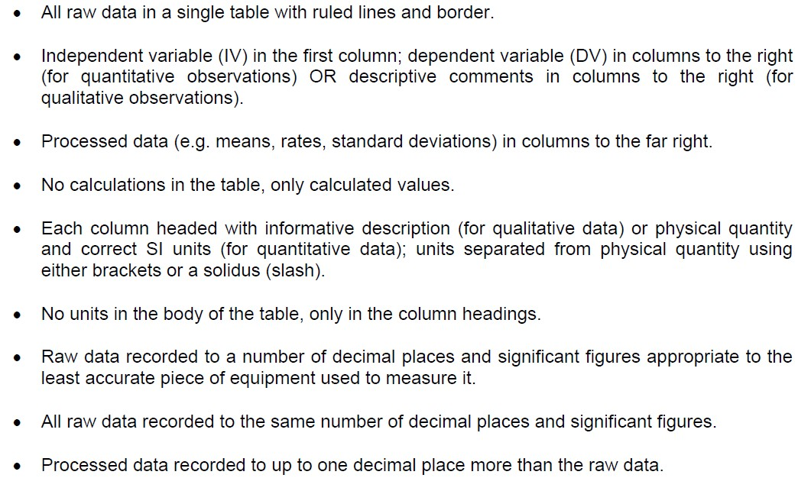

- The table shows a student’s results from an experiment looking at the effect of temperature on the activity of the enzyme amylase, which digests starch.

- What type of graph would you plot to show the results? Explain why. (The video at http://ed.ted.com/on/GV5hkNIA may be useful).
____________________________________________________________________________________________________________________________________________________________________________________________________________________________________________________________

- The time taken for the enzyme to digest the starch decreases as temperature increases from 25 to 35 degrees. Why do you think this is?
___________________________________________________________________________________________________________________________________________________________________________________________________________________________________________________________________________________________________________________________
_______________________________________________________________

- However, after 35 degrees, the time taken actually starts to increase. Why do you think this is?
__________________________________________________________________________________________________________________________________________________________________________________________________________________________________________________________________________________________________________________________________________________________________________________________
_______________________________________________________________

Task 4: Units – This task is worth 10 points
The ability to convert between units confidently is an incredibly important skill in A-level biology, particularly within the practical component, and is something that is frequently required when answering exam questions.
TASK: Fill in the missing name/symbol for each unit of measurement and how you would convert between each in the diagram below. Then complete the table to show the equivalent value for each measurement for the three different units.
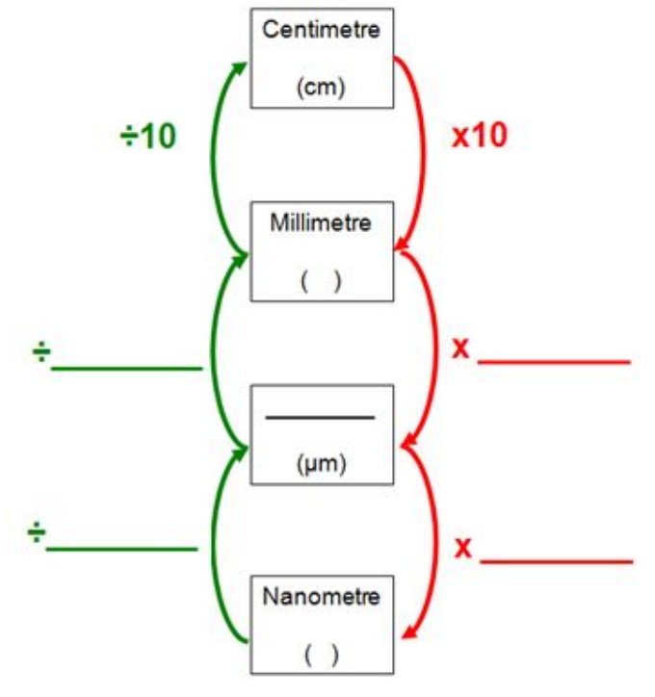

Nanometre | Micrometre | Millimetre
5 | 0.005 | 0.000005
1
 | 1
 |  | 1
 | 3
7
 |  | 0.5

Bonus question:
Which are not the same?

Task 5 – Extended writing – This task is worth 30 points
Essay writing is something that we will practice as it forms a key part of one of the biology exams. It requires the ability to bring together lots of different ideas/topics from the course and your own research into a bigger picture.
TASK: Write an essay on the biological importance of water.
Here are some ideas to get you going:
- Transport
- Temperature control
- Habitats
- Support

Use this space below to plan your essay and write/type it up on another piece of paper.

Task 6: Practical terminology – This task is worth 20 points
Understanding and being able to use correct scientific terminology when carrying out, or writing about, practical experiments is essential on the A-level course.
TASK: Using research and your own knowledge, define each of the following terms.
Term | Definition
Independent variable
Dependent variable
Control variables
Hypothesis
Null hypothesis
Correlation
Causal link
Directly proportional
Inversely proportional
Anomaly
Accuracy
Precision
Systematic error
Random error
Zero error
Uncertainty

