Preparing for A level – Study Support Pack: Summer 2022
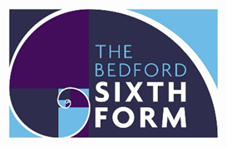

Subject: Ancient History

The aim of this pack is to help you bridge the gap between GCSE and A level. It is specific to one of the many A level subjects that are taught at The Bedford Sixth Form and we encourage you to work through all the relevant packs for the subjects that you would like to study.

www.bedfordsixthform.ac.uk

A Level Ancient History
Welcome, to A level Ancient History, which you have chosen to take this September. The booklet is designed to give you a flavour of what A level Ancient History is all about. The pack will introduce you to some core themes and skills, to aid your understanding of ancient history ready for sixth form. The work in this booklet will take a long time, so you can break it up. Don’t feel you need to complete it all in one go! You can complete the tasks in this booklet in the spaces provided. The completed work will need to be submitted in your first Ancient lesson in September and you will be given a mark out of a 100
Contact Olivia or Penny if you have any queries.
pcunningham@bedfordsixthform.ac.uk
oflynn@bedfordsixthform.ac.uk
A LEVEL COURSE OUTLINE
Year 12: Greece – Period study: Relations between Greek states and between Greek and non-Greek states, 492-404 BC | Year 12: Rome – Period study  The Julio-Claudian Emperors, 31 BC-AD 68 | Year 13: Greece – Depth Study: Culture and Politics of Athens, c460-c. 399 BC | Year 13: Rome Depth Study:  The Breakdown of the Late Republic, 88–31 BC
The challenge of the Persian Empire | Augustus | Athenian Political and social structure | The form of the Constitution
Greece in Conflict | Tiberius | The influence of thinking and ideas on Athenian society | The challenges to the Constitution
Peace and Conflict | Gaius (Caligula) | Art and Architecture and their significance in the culture of Athens | The means by which politicians achieved success
The Archidamian War | Claudius | Drama and Dramatic festivals and their significance in the culture of Athens | Social and Economic relationships and their importance in the breakdown of the Republic
The end of the Peloponnesian War and its aftermath | Nero | Religion and significance in the culture of Athens | The roles and importance of individuals in the breakdown of the Republic
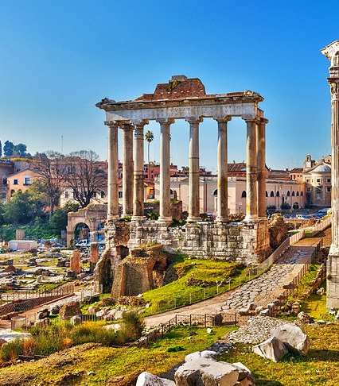
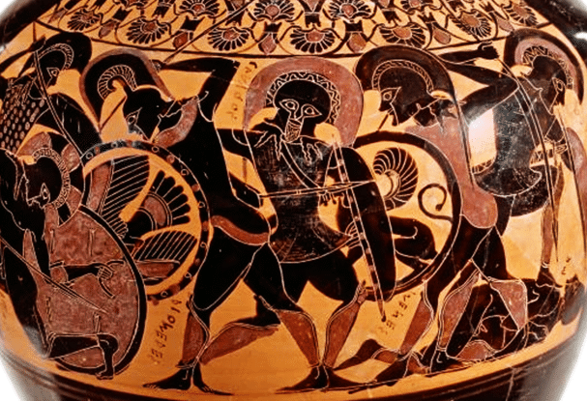
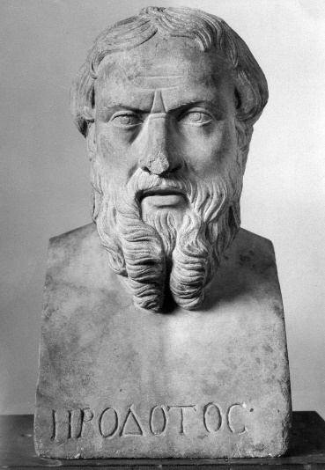

Useful resources
You will need to purchase the following 2 text books – they will see you through both Year 1 and Year 2

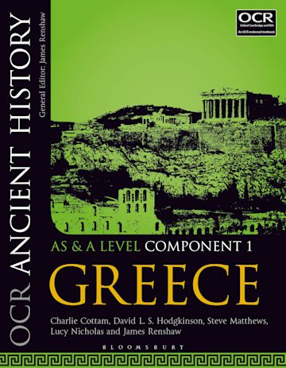
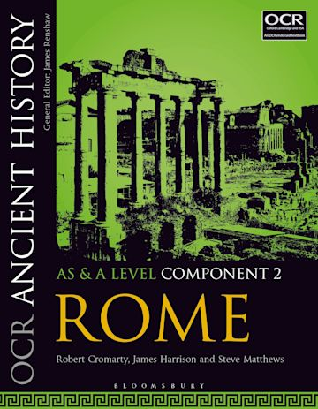

Additional books that you may like to read (you don’t necessarily have to buy and read all of these over the summer):
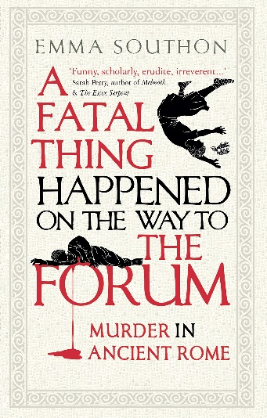
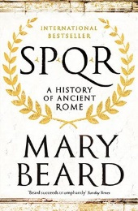
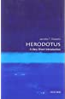
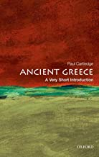

ANCIENT GREECE
1. Early Greek culture was heavily influenced by geography. Greek city states were isolated from one another by mountains or water. The seas, however, provided a vital link to the outside world. The Greeks became skilled sailors and traders. As they travelled, they acquired new ideas from foreign lands, which they adapted to their own needs.
2. Different forms of government evolved in Greece. At first, there was a monarchy. In a monarchy, a hereditary ruler exercises central power. In time, the power shifted to an aristocracy—or rule by the landholding elite. As trade expanded and a wealthy middle class emerged, the result was a form of government called an oligarchy— where power is in the hands of a small, wealthy elite.
3. A new method of fighting also emerged. The phalanx was a massive tactical formation of heavily armed foot soldiers. In the city state of Sparta, Spartans focused on developing strong military skills, paying less attention to trade, wealth, new ideas, or the arts.
4. In Athens, government evolved from a monarchy into an aristocracy. Under the aristocracy, discontent spread among ordinary citizens. Slowly Athens moved toward democracy, or government by the people.
5. Despite divisions among city-states, Greeks shared a common culture. They spoke the same language, honoured the same ancient heroes, participated in common festivals, and prayed to the same gods.
6. Greek thinkers used observation and reason to explain events. These thinkers were called philosophers, meaning “lovers of wisdom.” Philosophers explored many subjects, from mathematics and music, to logic, or rational thinking. They believed that through reason and observation, they could discover laws that governed the universe.
7. Some philosophers were interested in ethics and morality. In contrast, the Sophists believed that success was more important than moral truth. They developed skills in rhetoric, the art of skilful speaking. Ambitious men could use clever and persuasive rhetoric to advance their careers.
8. The philosopher Socrates was an outspoken critic of the Sophists. He believed in seeking truth and self-knowledge. Most of what we know about Socrates comes from his student Plato. Plato set up a school called the Academy where he taught his own ideas. Like Socrates, Plato emphasized the importance of reason.
9. Plato’s most famous student, Aristotle, also promoted reason as the guiding force for learning. He set up a school, the Lyceum, for the study of all branches of knowledge. While Plato argued that every object on Earth has an ideal form, Greek artists and architects reflected a similar concern with balance, order, and beauty. The most famous example of Greek architecture is the Parthenon. The basic plan of the Parthenon is a simple rectangle, with tall columns supporting a gently sloping roof.
10. Early Greek sculptors carved figures in rigid poses. Later, they emphasized more natural forms. Sculptors carved their subjects in a way that showed human beings in what was considered their most perfect, graceful form. In literature, the Greeks also developed their own style. Some Greek playwrights wrote tragedies, or plays that tell stories of human suffering, usually ending in disaster. Others wrote comedies, or humorous plays that mock customs or that criticize society.
11. History was also an important study for Greeks. Herodotus, often called the “Father of History,” stressed the importance of research. He visited many lands to collect and chronicle information from witnesses of actual events. Thucydides also recorded events as he experienced them. Both men set standards for future historians.
12. The most famous of Greek rulers, Alexander the Great, acquired the throne and began organizing forces to conquer Persia. Alexander was victorious. Once much of the Persian empire fell under his control, he advanced into India. Unexpectedly in 323 B.C., Alexander died at the age of 33 in Persia from a fever. Although his empire collapsed soon after, he is credited with spreading Greek culture from Egypt to the borders of India. Local people assimilated, or absorbed, Greek ideas. In turn, Greek settlers adopted local customs. Gradually, a new Hellenistic culture emerged that blended Greek, Persian, Egyptian, and Indian influences.
13. At the very heart of the Hellenistic world stood the magnificent city of Alexandria, founded in Egypt by Alexander. Its great library was among the greatest scientific and cultural centres of the age. Like Alexandria, cities of the Hellenistic world employed many architects and artists. Temples, palaces, and other public buildings were larger and grander than the buildings of classical Greece. The elaborate new style reflected the desire of Hellenistic rulers to glorify themselves as godlike.
14. During the Hellenistic age, scholars built on earlier Greek, Babylonian, and Egyptian knowledge. In mathematics, Pythagoras derived a formula to calculate the relationship between the sides of a right triangle. The astronomer Aristarchus developed the theory of a heliocentric, or sun-centred, solar system. Another scientist, Archimedes, applied the principles of physics to make practical inventions. In the field of medicine, the Greek physician Hippocrates studied the causes of illnesses and looked for cures. Greek works in the arts and sciences set a standard for later Europeans. Greek ideas about law, freedom, justice, and government continue to influence political thinking today

a) Write the correct term or name using a word found in bold print from the article
1. __________________________________ sun-centred
2. _________________________________ rational thinking using reasoning
3. ___________________________________ massive tactical formation of heavily armed foot soldiers
4. ___________________________________ lovers of wisdom
5. ___________________________________ where power is in the hands of a small, wealthy elite
6. ___________________________________ when a hereditary ruler exercises central power
7. _________________________________ to absorb or adopt customs, ideas, values, etc.
8. ___________________________________ government by the people
9. ___________________________________ plays that tell stories of human suffering, usually ending in disaster
10. ___________________________________ rule by the landholding elite
11. __________________________________ humorous plays that mock customs or that criticize society
12. __________________________________ The most famous example of Greek architecture
13. ___________________________________ The art of skilful speaking

b) The article has an underlined word in each paragraph. Write the correct word alongside the word or phrase that could be used to replace it and still keep the original meaning in the sentence.
14. fancy______________________
15. developed _______________________
16. founded _____________________
17. cut off ______________________
18. laws ____________________________
19. began _______________________

20. Compare/contrast paragraphs 1 and 2.
- What is similar?

- How are they different?

21. What is the main idea of paragraph 6?

22. Describe a cause and effect found in paragraph 8.

23. Use context clues to determine the meaning of the word “ideal” in paragraph 9 and explain your reasoning.

24. What different forms of governments evolved in ancient Greece?

25. What reforms did Cleisthenes make?

26. What did Greek philosophers use to explain events?

27. What two forms of drama did the Greeks develop?

28. How was Alexandria typical of a Hellenistic city?

29. On what was Hellenistic scholarship based?

30,31,32 - Complete the following chart:
Paragraph | Main idea | Supporting detail 1 | Supporting detail 2
12
13
14

You will be awarded 1 mark for each correct answer (Total: 32 marks)

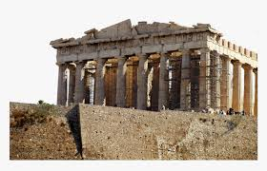
Ancient Greece- Virtual Field Trip Discovery Hunt
Directions: You will be going on a virtual field trip to unlock the mysteries of Ancient Greece. Below are clues that will require you to visit certain locations of historical significance on a map. Once you have cracked the clue, answer the question that goes along with each statement.
Use the site: http://www.acropolisvirtualtour.gr
- Seen as a symbol of victory from Persian invaders, this location was dedicated to Athena and is one of the most recognizable structures of Ancient Greece.
Name of structure________________________________________ Location:_____________________
How many pillars do you see at the location facing the city?________

- Long known as a sanctuary of worship, this area was known to have a wooden statue of a Goddess and was protected by a strong tower.
Name of Location _____________________________ Location:___________________
Describe what is carved into the top of the structure: ________________________________________________________________

- A severe earthquake brought down at least a portion of this structure. This structure was used as an extra type of fortification from the East.
Name of Structure___________________________________ Location:________________________________
Description of structure:________________________________________________________________________________

____________________________________________________________________

- Part of the additional fortification system, it was part of the western entrance to Acropolis. Eventually part of the structure was converted to a church.
What is this called?_______________________________________________________
Which bishop lived here for some time?__________________________________________
What is the north wing of this structure known as? ______________________________________________________________________________________

- This gate was named after a French archaeologist, it is located west of Propylaea.
Name of the gate:_________________________________________________________
What year was the area of the gate excavated?________
What were the names of the blocks used to build this structure?_ _____________________________________________________________________

- This structure displays a series of statues of women. Believe to have marked the grave of an ancient king.
What are the figures known as or called?__________________________________
How many figures exist in front of the structure?__________________
Where is it located?____________________________________________

You will be awarded 1 mark for each correct answer (Total: 18 marks)

Ancient Rome: An Introduction with Mary Beard

Mary Beard is the Head of the Classical Civilisation department at the University of Cambridge. She is famous for her many BBC documentaries on Rome and her game-changing contributions to the field of Classics and Ancient History.

To understand Rome, you need to know how the Romans viewed themselves. The best way to do this is to understand what the Romans believed about the foundation of their city and culture.

Watch the documentary by Mary Beard and answer the following questions. These are designed to give you a solid overview of the key events leading up to the rule of Emperor Augustus, which is where we shall begin in September!

Before we begin… What do you know about the story of Romulus and Remus?
Do you think the foundation story is a myth, legend or history?

Please watch Ultimate Rome: Episode 1 and I strongly advise watching the other episodes too, though this is optional. If you do not have access to the link, search “Mary Beard BBC Ultimate Rome, episode 1” on YouTube and you should find it easily. Remember to take thorough notes!

You may wish to write your answers on a separate sheet of paper.

- In what ways do you think the story of Romulus and Remus impacted the way that Romans viewed their cultural identity?

- How can tombs and other funerary monuments help us understand the mind-set and beliefs of people in the ancient world? How does the tomb at the beginning of the documentary inform us about the foundations of Rome?

- What was the ‘problem’ with being a Roman in the first few hundred years of the city being built? Why did they have a bad reputation? How do you think this reputation shaped the way the Romans viewed themselves throughout history?

- What was the significance of the Carthaginian war for the Roman people? Why was it so revolutionary and important that they won this war? How did it change things in the swiftly expanding Roman Empire?

- How did the conquest of Corinth and the Greek world change the Roman culture? How might this change the way that the Romans behaved and thought about themselves?

- Who was Pompey the Great, what did he do, and why was he so important for Rome and the Roman people?

- How did Julius Caesar “outdo” Pompey the Great? What was new, ground-breaking or barbaric about what he did?

- In what ways was Emperor Augustus similar and/or different to the leaders who came before him? What did he find important, and how do you think this influenced the success of the Empire?

This section is worth 8 marks.

Ancient Authors: Who’s who?

There are several ancient writers that you need to know all about to be successful in your A-Level exams. You need to know their names, backgrounds, published works, strengths and limitations as a source. An example has been provided for you.

If accessing this workbook offline, you may wish to complete this task on a separate sheet of paper to allow enough room to fill all the rows.
Name | Background | Published works | Strengths | Limitations
Appian | - Historian/ biographer  - Born AD95  - Lived under the reign of Emperor Antinous Pius  - Greek from Alexandria  - Equestrian Class  - Lawyer | Roman History - including five books on The Civil Wars from the Murder of Tiberius Gracchus 133BC to the defeat of Sextus Pompey 36BC | - Perceptive about the realities of power  - Good at writing about military matters  - Preserved information that would have been lost | - Very casual about dates  - Allows himself to rearrange events to create more drama e.g. his account of the murder of Caesar is different from Dio, Plutarch and Suetonius  - Needs to be used with caution  - Often critical of and unsympathetic toward republican institutions and popular movements.
Arrian
Aristophanes
Aristotle
Cicero
Caesar
Curtis Rufus
Demosthenes
Diodorus Siculus
Herodotus
Horace
Josephus
Ovid
Plutarch
Pliny the Younger
Sallust
Seneca
Suetonius
Thucydides
Tacitus
Velleius Paterculus
Virgil
Xenophon

This section will be awarded up to 22 marks. 1 mark will be given per complete row.

Literature: Book Review

I would like you to read one book over the summer that is based in the ancient world that you have not read before. This can be fiction or non-fiction.
Reading is a vital part of studying Ancient History, especially as you will need to read many sources by ancient authors and reference them from memory in your exams.
You will need to write a short review on the book you have chosen. You may borrow the book from your local library or purchase a physical copy/audio book if you prefer.

Here is a list of the books we would recommend, but you may find/choose your own.
If you have already read any on the list, then add your star rating next to them!

Fiction:
- Song of Achilles by Madeline Miller
- Circe by Madeline Miller
- A Thousand Ships by Natalie Haynes
- Lore Olympus by Rachel Smythe (available for free via Webtoon App)
- The Wolf Den by Elodie Harper
- The Gates of Athens by Conn Iggulden
- Protector by Conn Iggulden
- Emperor Series by Conn Iggulden
- Cicero Trilogy by Robert Harris

Non-Fiction (most available as fantastic audiobooks):
- Mythos by Stephen Fry
- Heroes by Stephen Fry
- Troy by Stephen Fry
- Pandora's Jar by Natalie Haynes
- SPQR by Mary Beard
- A Fatal Thing Happened On The Way To The Forum by Emma Southon
- Agrippina by Emma Southon
- Caesar by Adrian Goldsworthy
- Augustus by Adrian Goldsworthy
- Antony and Cleopatra by Adrian Goldsworthy
- Philip and Alexander by Adrian Goldsworthy
- Cicero by Anthony Everitt
- Persian Fire by Tom Holland
- Dynasty by Tom Holland
- Rubicon by Tom Holland
- 24 Hours in Ancient Rome by Philip Matyszak
- 24 Hours in Ancient Athens Philip Matyszak

Enter book review here:
Star Rating (out of 5):-

Summary of the book :-

Most interesting fact/ part :-

Do you feel it has helped to expand your knowledge of the ancient world? Explain your answer:-

Would you recommend it? (Why/Why not?):-

This summary will be awarded up to 5 marks per section of the review (20 marks total).

Total marks for the whole booklet: 100

