Preparing for A Level

Study Support Pack Summer 2022

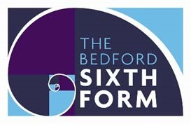
Subject: Law

The aim of this pack is to help you bridge the gap between GCSE and A Level. It is specific to one of the many A Level subjects that are taught at The Bedford Sixth Form and we encourage you to work through all the relevant packs for the subjects that you would like to study.

www.bedfordsixthform.ac.uk

Name:

Key Information

Your Teachers
Mel Stretton
Sabba Anjum

Essential Items
Below is a list of all the essential items that you will be required to bring with you in September:
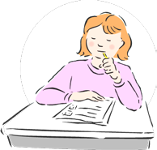
- A4 Ringbinder
- A4 Dividers
- A4 Lined Paper
- Pens/Pencil/Highlighters
- Flash Cards

If you wish to purchase a textbook, the only one that has been authorised by the exam board is below. This is not an essential, just personal preference.
AS Law Textbook (AQA A-Level for Year 1/AS – Jacqueline Martin & Nicholas Price [2017])

Exam Information
- Exam board: AQA
https://www.aqa.org.uk/subjects/law/as-and-a-level/law-7162

- Exams:
o Paper 1 - Unit 1 and Unit 2 o Paper 2 - Unit 1 and Unit 3

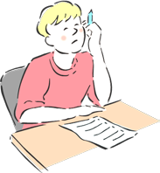

Year 1 Overview
Unit 1  (Mel & Sabba)  - The Nature and Rule of Law  - Parliamentary Law Making  - Delegated Legislation  - Statutory Interpretation  - Judicial Precedent  - European Union  - Law Reform  - Civil Courts and ADR  - Criminal Courts, Lay People & Sentencing  - Legal Personnel & Judiciary  - Access to Justice and Funding | This is all about how laws are made, and all the procedures used in our legal system.

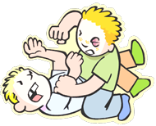

Unit 2
–

Crime

(
Sabba)
•

Principles of Criminal Liability
•

Non-Fatal Offences Against the Persons

You need to be able to
spot a crime and
decide if someone is
guilty.

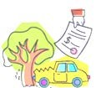

Unit 3
–

Tort

(
Mel)
•

Negligence
•

Occupier’s Liability
•

Damages
This is looking at how
to sue someone for
compensation.

Case Research (30 points)
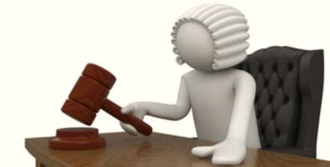
Please find a news article of a UK case which you find interesting and has finished. This may be a local or national matter, heard in any Court and be old or new. You may find this on the internet, in local or national newspapers or books.
You then need to answer the questions below in the space provided.
Is it a Civil or Criminal case? Explain why you think so.

Which court was it heard in and why do you think it was there?

Briefly explain what happened.

What was the outcome?

What are your views on this outcome? Include what beliefs you had that have affected your reasoning.
Do you think this was a moral decision or logical? Explain.

Why did you choose this case - what interested you about it?

Bring the report of the case to your first Law lesson in September and be prepared to discuss it.

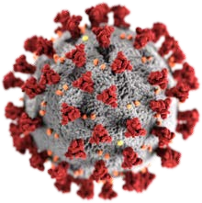 Coronavirus Act 2020 (30 points)

Please research the Act above and complete the activities below. Make sure you tell us which section of the Act (and subsection if needed), that you have used as your source.

How long can you extend the regulations about the retention of fingerprint on file?

As it relates to potentially infectious persons, what three ways can a public health officer direct or remove someone?

On the same page you should be able to tell me what two offences can be committed if the above rules aren’t met by the infected person.

Who is it that can give the directions to close schools? Can you tell me that person’s name?

Unit 1 (20 points)
Please use this page to make a mind map outlining all the reasons that you think we have laws.

Purpose
of Laws

What is the difference between a solicitor and barrister?

What is the difference between a judge and a magistrate?

Think of 5 celebrities who you think would be able to be magistrates, and explain why in this space. Use this video I have made to help you decide: https://www.youtube.com/watch?v=mCTIjx-Icc4

U2 - Crime (20 points)
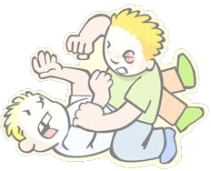

Please watch this link and then complete the boxes below.
https://www.youtube.com/watch?v=_j2prl_tuY8

How many crimes have been committed? Can you name them and state where they have occurred in the clip?

If Smithy was to die. Do you think that the offender should be charged with murder? Can you explain your reasoning?

In order for a person to be found guilty of a criminal offence, the prosecution have to prove two elements:
Actus reus + Mens rea = criminal offence
Research these terms and in one sentence, describe which part of the crime this is referring to. You must use your own words, please don’t copy and paste.
Extra tips: do not use Wikipedia and avoid anywhere that is not the UK.
Actus reus –

Mens rea –

Look at the following statements, which element do they refer to? Explain your decision.

- “I want to steal a car”

- “I’ve punched someone in the face”

- “I just shot a man and I’m glad!”

Extra Resources

We always encourage extra reading and research, here are some useful links for you to get you started.

- Information on how a law is made, with links to videos.
https://www.parliament.uk/about/how/laws/passage-bill/

- Future acts (bills) being debated in Parliament at the moment.
https://services.parliament.uk/bills/

- A Level Law information and cases.
https://www.e-lawresources.co.uk/

- Study stack is a good place to store your information and create online games and flashcards. It also has an app so you can add to it throughout the year. Search MrsMel or Mr Lovell to get you started.
https://www.studystack.com/

- Careers in law. https://www.allaboutlaw.co.uk/
https://www.prospects.ac.uk/jobs-and-work-experience/jobsectors/law-sector/law-careers

You Tube can be a useful tool too, here are some links to a few channels we find helpful to subscribe to.

- UK Parliament https://www.youtube.com/user/UKParliament/

- Law Teacher https://www.youtube.com/channel/UCwPjzlae4KLq9PmEwjNeEpw

- Law Bank https://www.youtube.com/user/TheLawBank

- The Law Simplified https://www.youtube.com/channel/UCCyS1rOQP8eLHHkUDe6HjmA

We look forward to meeting you all soon!

